
V1.0.1

Network Camera
User‘s Manual

Foreword
General
This manual introduces the functions, configuration, general operation, and system maintenance of network camera. Read carefully before using the platform, and keep the manual safe for future reference.
Safety Instructions
The following signal words might appear in the manual.
Signal Words | Meaning
 | Indicates a medium or low potential hazard which, if not avoided, could result in slight or moderate injury.
 | Indicates a potential risk which, if not avoided, could result in property damage, data loss, reductions in performance, or unpredictable result.
 | Provides additional information as a supplement to the text.
Revision History
Version | Revision Content | Release Date
V1.0.1 | Updated the language. | October 2023
V1.0.0 | First release. | September 2023
Privacy Protection Notice
As the device user or data controller, you might collect the personal data of others such as their face, audio, fingerprints, and license plate number. You need to be in compliance with your local privacy protection laws and regulations to protect the legitimate rights and interests of other people by implementing measures which include but are not limited: Providing clear and visible identification to inform people of the existence of the surveillance area and provide required contact information.
About the Manual
● The manual is for reference only. Slight differences might be found between the manual and the product.
● We are not liable for losses incurred due to operating the product in ways that are not in compliance with the manual.
● The manual will be updated according to the latest laws and regulations of related jurisdictions. For detailed information, see the paper user’s manual, use our CD-ROM, scan the QR code or visit our official website. The manual is for reference only. Slight differences might be found between the electronic version and the paper version.
● All designs and software are subject to change without prior written notice. Product updates might result in some differences appearing between the actual product and the manual. Please contact customer service for the latest program and supplementary documentation.
● There might be errors in the print or deviations in the description of the functions, operations and technical data. If there is any doubt or dispute, we reserve the right of final explanation.
● Upgrade the reader software or try other mainstream reader software if the manual (in PDF format) cannot be opened.
● All trademarks, registered trademarks and company names in the manual are properties of their respective owners.
● Please visit our website, contact the supplier or customer service if any problems occur while using the device.
● If there is any uncertainty or controversy, we reserve the right of final explanation.

Important Safeguards and Warnings
This section introduces content covering the proper handling of the device, hazard prevention, and prevention of property damage. Read carefully before using the device, and comply with the guidelines when using it.
Transportation Requirements
● Transport the device under allowed humidity and temperature conditions.
● Pack the device with packaging provided by its manufacturer or packaging of the same quality before transporting it.
● Do not place heavy stress on the device, violently vibrate or immerse it in liquid during transportation.
Storage Requirements
● Store the device under allowed humidity and temperature conditions.
● Do not place the device in a humid, dusty, extremely hot or cold site that has strong electromagnetic radiation or unstable illumination.
● Do not place heavy stress on the device, violently vibrate or immerse it in liquid during storage.
Installation Requirements
● Strictly comply with the local electrical safety code and standards, and check whether the power supply is correct before operating the device.
● Please follow the electrical requirements to power the device.
◇ When selecting the power adapter, the power supply must conform to the requirements of ES1 in IEC 62368-1 standard and be no higher than PS2. Please note that the power supply requirements are subject to the device label.
◇ We recommend using the power adapter provided with the device.
● Do not connect the device to two or more kinds of power supplies, unless otherwise specified, to avoid damage to the device.
● The device must be installed in a location that only professionals can access, to avoid the risk of non-professionals becoming injured from accessing the area while the device is working. Professionals must have full knowledge of the safeguards and warnings of using the device.
● Do not place heavy stress on the device, violently vibrate or immerse it in liquid during installation.
● An emergency disconnect device must be installed during installation and wiring at a readily accessible location for emergency power cut-off.
● We recommend you use the device with a lightning protection device for stronger protection against lightning. For outdoor scenarios, strictly comply with the lightning protection regulations.
● Ground the function earthing portion  of the device to improve its reliability (certain models are not equipped with earthing holes). The device is a class I electrical appliance. Make sure that the power supply of the device is connected to a power socket with protective earthing.
● The dome cover is an optical component. Do not directly touch or wipe the surface of the cover during installation.
Operation Requirements
● The cover must not be opened while the device is powered on.
● Do not touch the heat dissipation component of the device to avoid the risk of getting burnt.
● Use the device under allowed humidity and temperature conditions.
● Do not aim the device at strong light sources (such as lamplight, and sunlight) when focusing it, to avoid reducing the lifespan of the CMOS sensor, and causing overbrightness and flickering.
● When using a laser beam device, avoid exposing the device surface to laser beam radiation.
● Prevent liquid from flowing into the device to avoid damage to its internal components.
● Protect indoor devices from rain and dampness to avoid electric shocks and fires breaking out.
● Do not block the ventilation opening near the device to avoid heat accumulation.
● Protect the line cord and wires from being walked on or squeezed particularly at plugs, power sockets, and the point where they exit from the device.
● Do not directly touch the photosensitive CMOS. Use an air blower to clean the dust or dirt on the lens.
● The dome cover is an optical component. Do not directly touch or wipe the surface of the cover when using it.
● There might be a risk of electrostatic discharge on the dome cover. Power off the device when installing the cover after the camera finishes adjustment. Do not directly touch the cover and make sure the cover is not exposed to other equipment or human bodies
● Strengthen the protection of the network, device data and personal information. All necessary safety measures to ensure the network security of the device must be taken, such as using strong passwords, regularly changing your password, updating firmware to the latest version, and isolating computer networks. For the IPC firmware of some previous versions, the ONVIF password will not be automatically synchronized after the main password of the system has been changed. You need to update the firmware or change the password manually.
Maintenance Requirements
● Strictly follow the instructions to disassemble the device. Non-professionals dismantling the device can result in it leaking water or producing poor quality images. For a device that is required to be disassembled before use, make sure the seal ring is flat and in the seal groove when putting the cover back on. When you find condensed water forming on the lens or the desiccant becomes green after you disassembled the device, contact after-sales service to replace the desiccant. Desiccants might not be provided depending on the actual model.
● Use the accessories suggested by the manufacturer. Installation and maintenance must be performed by qualified professionals.
● Do not directly touch the photosensitive CMOS. Use an air blower to clean the dust or dirt on the lens. When it is necessary to clean the device, slightly wet a soft cloth with alcohol, and gently wipe away the dirt.
● Clean the device body with a soft dry cloth. If there are any stubborn stains, clean them away with a soft cloth dipped in a neutral detergent, and then wipe the surface dry. Do not use volatile solvents such as ethyl alcohol, benzene, diluent, or abrasive detergents on the device to avoid damaging the coating and degrading the performance of the device.
● The dome cover is an optical component. When it is contaminated with dust, grease, or fingerprints, use degreasing cotton moistened with a little ether or a clean soft cloth dipped in water to gently wipe it clean. An air gun is useful for blowing dust away.
● It is normal for a camera made of stainless steel to develop rust on its surface after being used in a strong corrosive environment (such as the seaside, and chemical plants). Use an abrasive soft cloth moistened with a little acid solution (vinegar is recommended) to gently wipe it away. Afterwards, wipe it dry.

Table of Contents
Foreword I
Important Safeguards and Warnings III
1 Overview 1
1.1 Introduction 1
1.2 Network Connection 1
1.3 Functions 1
1.3.1 Basic Functions 1
1.3.2 Intelligent Functions 2
2 Device Initialization 3
3 Login 4
3.1 Logging in to the Webpage 4
3.2 Resetting Password 4
4 Preview 6
5 AI Preview 8
6 Playback 9
6.1 Playback Page 9
6.2 Playing Video or Picture 10
6.3 Clipping Video 12
6.4 Downloading Video or Picture 12
6.4.1 Downloading a Single File 12
6.4.2 Downloading Files in Batches 12
7 Setting 14
7.1 System 14
7.1.1 System Setting 14
7.1.1.1 Basic Info 14
7.1.1.2 Time Settings 14
7.1.2 Maintenance 15
7.1.2.1 Upgrade and Maintenance 15
7.1.2.2 System Log 16
7.1.3 Security 17
7.1.4 User Management 19
7.1.4.1 User Mana. 19
7.1.4.1.1 Username 19
7.1.4.1.2 User Group 20
7.1.4.2 Online User 22
7.1.4.3 PW Reset 22
7.2 Network 22
7.2.1 TCP/IP 22
7.2.2 Port 23
7.2.3 P2P 25
7.2.4 DDNS 25
7.2.5 Email 26
7.2.6 PPPoE 28
7.2.7 UPnP 28
7.2.8 SNMP 29
7.2.9 Bonjour 31
7.2.10 Multicast 32
7.2.11 802.1x 32
7.2.12 QoS 33
7.2.13 RTMP 34
7.2.14 FTP 35
7.2.15 NAS 35
7.2.16 HTTPS 36
7.2.17 Firewall 38
7.2.18 ONVIF 40
7.2.19 Remote Log Records 40
7.3 Video/Audio 40
7.3.1 Video 40
7.3.2 Audio 42
7.3.2.1 Configuring Audio 42
7.3.2.2 Configuring Alarm Audio 43
7.4 Image 44
7.4.1 Display Settings 44
7.4.2 OSD 47
7.4.3 Privacy Mask 48
7.5 Event 49
7.5.1 Basic Event 49
7.5.1.1 Configuring Motion Detection 49
7.5.1.2 Configuring Audio Detection 50
7.5.1.3 Configuring Video Tampering 50
7.5.1.4 Configuring Scene Changing 51
7.5.1.5 Configuring Alarm Linkage 52
7.5.2 VCA Option 53
7.5.3 Line Crossing and Intrusion 53
7.5.4 VCA Advanced 55
7.5.4.1 People Counting 55
7.5.4.1.1 People Counting Configuration 55
7.5.4.1.2 Viewing People Counting Report 55
7.5.4.2 Heat Map 56
7.5.4.2.1 Heat Map Configuration 56
7.5.4.2.2 Viewing Heat Map Report 56
7.5.4.3 Object Monitoring 56
7.5.4.4 Face Detection 57
7.5.4.5 Metadata 58
7.5.4.5.1 Metadata Configuration 58
7.5.4.5.2 Viewing Metadata Report 59
7.5.4.6 Metadata Picture Info 59
7.5.5 Exception 60
7.6 Storage 61
7.6.1 Configuring Schedule 61
7.6.1.1 Video Recording 61
7.6.1.2 Holiday Schedule 61
7.6.2 Configuring Storage 62
7.6.2.1 Storage Location 62
7.6.2.2 Local Storage 63
7.6.3 Configuring Recording Control 63
7.6.4 Snapshot 64
7.6.4.1 Configuring Snapshot Parameters 64
7.6.4.2 Configuring Snapshot Schedule 65
Appendix 1 Cybersecurity Recommendations 66

1 Overview

1.1 Introduction
IP camera (Internet Protocol camera), is a type of digital video camera that receives control data and sends image data through internet. They are commonly used for surveillance, requiring no local recording device, but only a local area network.
IP camera is divided into single-channel camera and multi-channel camera according to the channel quantity. For the multi-channel camera, you can set the parameters for each channel.

1.2 Network Connection
In the general IPC network topology, IPC is connected to PC through network switch or router.
Figure 1-1 General IPC network
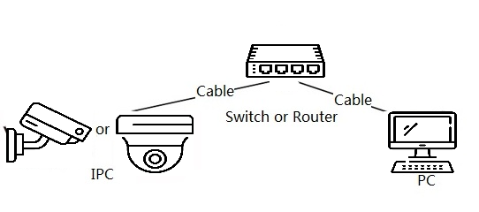

1.3 Functions
Functions might vary with different devices.

1.3.1 Basic Functions
Real-time Monitoring
● Preview.
● When live viewing the image, you can enable audio, voice talk and connect monitoring center for quick processing on the abnormality.
● Adjust the image to the proper position by PTZ.
● Snapshot and triple snapshot abnormality of the monitoring image for subsequent view and processing.
● Record abnormality of monitoring image for subsequent view and processing.
● Configure coding parameters, and adjust live view image.
Record
● Record automatically as schedule.
● Play back recorded video and picture as needed.
● Download recorded video and picture.
● Alarm linked recording.
Account
● Add, edit and delete the user group, and manage user authorities according to user group.
● Add, edit and delete the user, and configure user authorities.
● Change password of the user.

1.3.2 Intelligent Functions
Alarm
● Set alarm prompt mode and tone according to alarm type.
● View alarm prompt message.
Video Detection
● Motion detection, video tampering detection and scene changing detection.
● When an alarm is triggered, the system performs actions such as recording, alarm output, sending email, and taking snapshot.
Audio Detection
● Detection of abnormal audio detection and intensity change.
● When an alarm is triggered, the system performs linkages such as recording, alarm output, sending email, and snapshot.
IVS
● Detection of regional intrusion, line crossing and intrusion.
● When an alarm is triggered, the system performs linkages such as recording, alarm output, sending email, and snapshot.

2 Device Initialization
Device initialization is required for the first-time use. This manual is based on the operation on the webpage. You can also initialize device through ConfigTool, NVR, or platform devices.
● To ensure the device safety, keep the password properly after initialization and change the password regularly.
● When initializing device, keep the IP of computer and device IP in the same network.
Procedure
Step 1 Open IE browser, enter the IP address of the device in the address bar, and then press the Enter key.
The IP is 192.168.1.101 by default.
Step 2 Set the password for admin account.
Figure 2-1 Device initialization
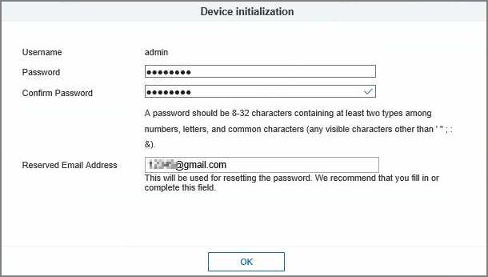
Table 2-1 Description of password configuration
Parameter | Description
Username | The default username is admin.
Password | The password must consist of 8 to 32 non-blank characters and contain at least two types of characters among upper case, lower case, number, and special character (excluding ' " ; : &). Set a high security level password according to the password security notice.
Confirm password
Reserved email | Enter an email address for password resetting, and it is enabled by default.  When you need to reset the password of the admin account, a security code for password resetting will be sent to the reserved email address.
Step 3 Click OK.

3 Login

3.1 Logging in to the Webpage
This section introduces how to log in to the webpage. Here we take Chrome as an example.
● You need to initialize the camera before logging in to the webpage. For details, see "2 Device Initialization".
● Follow the instruction to download and install the plug-in for the first login.
Procedure
Step 1 Open IE browser, enter the IP address of the camera (192.168.1.108 by default) in the address bar, and then press Enter.
Step 2 Enter the username and password.
The username is admin by default.
Click Forgot password?, and you can reset the password through the email address that is set during the initialization. For details, see "3.2 Resetting Password".
Figure 3-1 Login
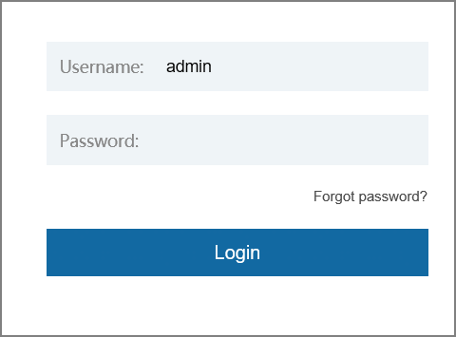
Step 3 Click Login.

3.2 Resetting Password
When you need to reset the password for the admin account, there will be a security code sent to the entered email address which can be used to reset the password.
Prerequisites
You have enabled password resetting service. For details, see "2 Device Initialization".
Procedure
Step 1 Open IE browser, enter the IP address of the device in the address bar, and then press Enter.
Figure 3-2 Login
Step 2 Click Forgot password?, and then you can reset the password through the email address that is set during the initialization.

4 Preview
Log in to the webpage, and the Preview page is displayed.
Figure 4-1 Preview
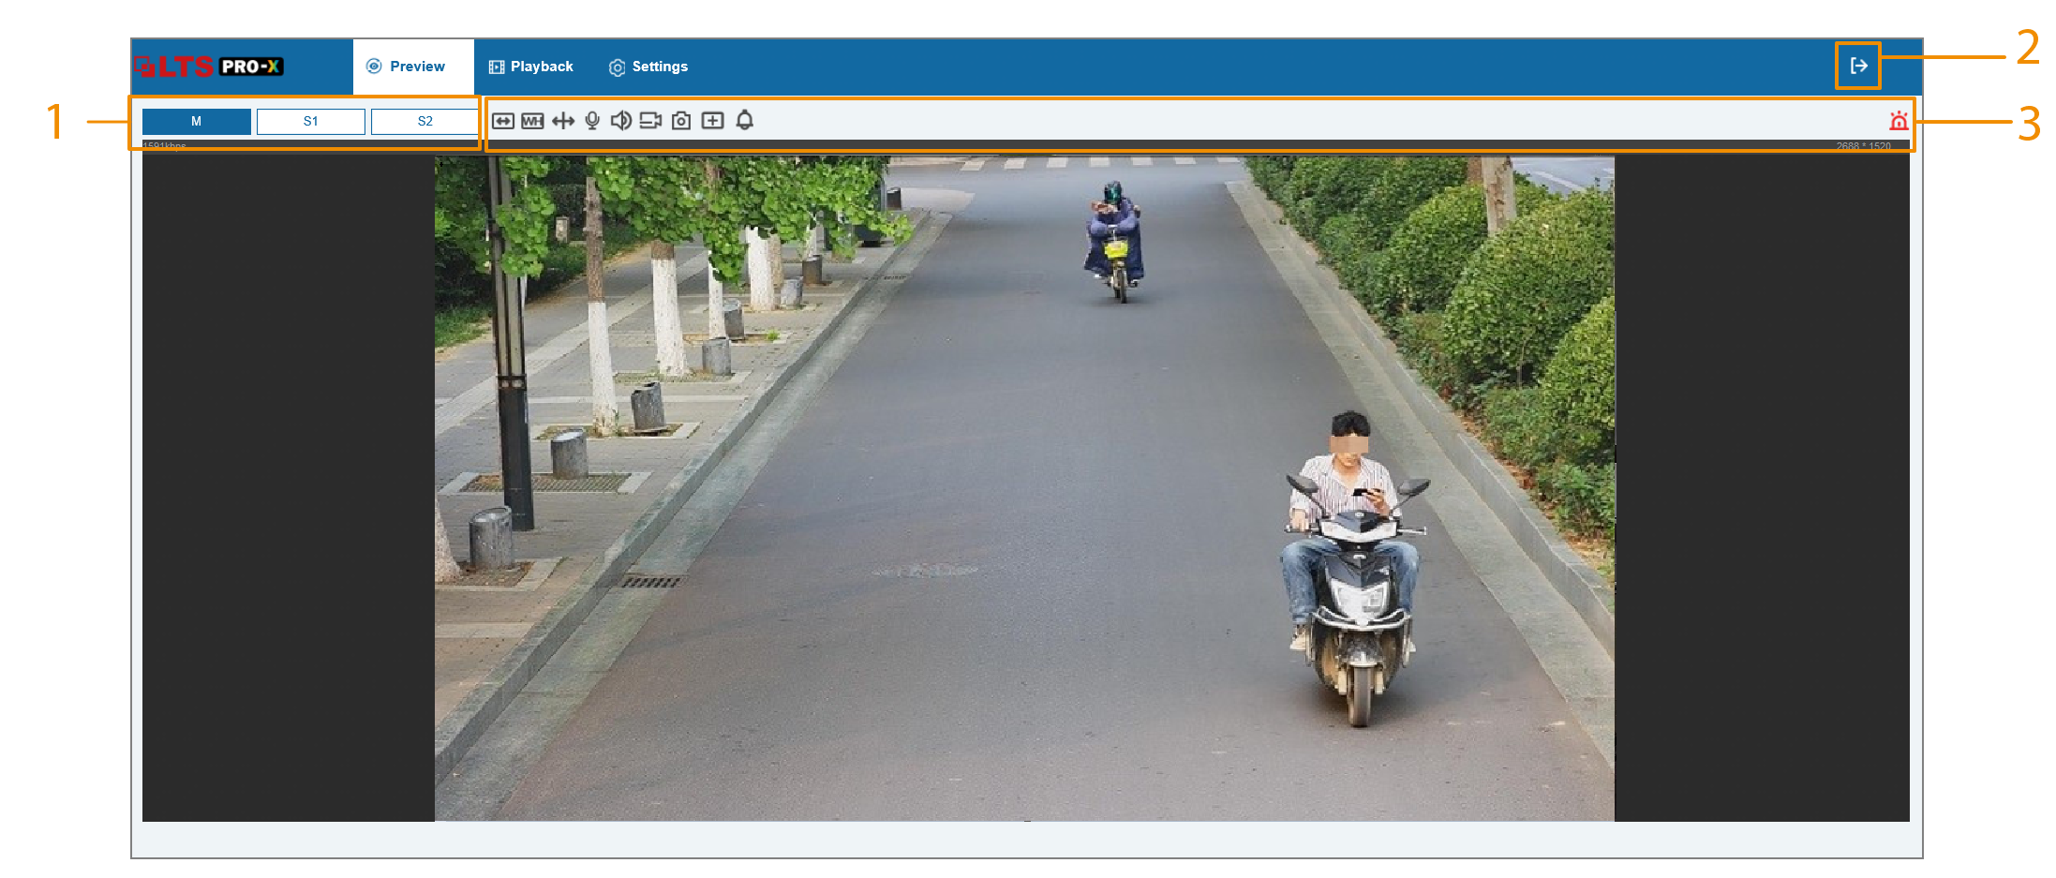
Table 4-1 Function bars description
No. | Parameter/Icon | Description
1 | M (Main Stream) | It has large bit stream value and image with high resolution, but requires large bandwidth. This option can be used for storage and monitoring.
1 | S1 (Sub Stream 1) | It has small bit stream value and smooth image, and requires little bandwidth. This option is normally used to replace main stream when bandwidth is not enough.
1 | S2 (Sub Stream 2)
2 | Exit | Click the icon, and then the system will log out to go to the login page.
3 |  | Full screen. Click the icon to enter full screen mode; double-click or press Esc to exit.
3 |  | Aspect ratio. Click the icon to resume original ratio or change ratio.
3 |  | VCA (Video Content Analysis). Displays the configured intelligent rule lines.
3 |  | Intercom. Click the icon to enable or disable the voice interaction.
3 |  | Sound. Click the icon to enable or disable audio output.
3 |  | Video recording. Click the icon to record video, and it will be saved to the configured storage path.
3 |  | Snapshot. Click the icon to capture one picture of the current image, and it will be saved to the configured storage path.
3 |  | Local zoom. You can zoom in or out the video image through two methods.  ● Click the icon, and then select an area in the video image to zoom in; right-click on the image to resume the original size. In zoom in state, drag the image to check other area.  ● Click the icon, and then scroll the mouse wheel in the video image to zoom in or out.
3 |  | Alarm. Displays the status of alarm sound.  Click the icon to enable or disable the alarm sound forcibly.
3 |  | Alarm output. Enable or disable the alarm output linkage.

5 AI Preview
You can select in Face Detection mode or Video Metadata mode.
Prerequisites
● Only IE browser supports this page.
● Make sure you have enabled the corresponding function in settings page.
Procedure
Step 1 Log in to the webpage of the device.
Step 2 Select AI Preview page.
Step 3 In the lower-right page, click , and then select the mode in the VCA Option drop-down list.
Step 4 Select the displayed attributes, and then click Save.
Figure 5-1 AI preview (face detection)
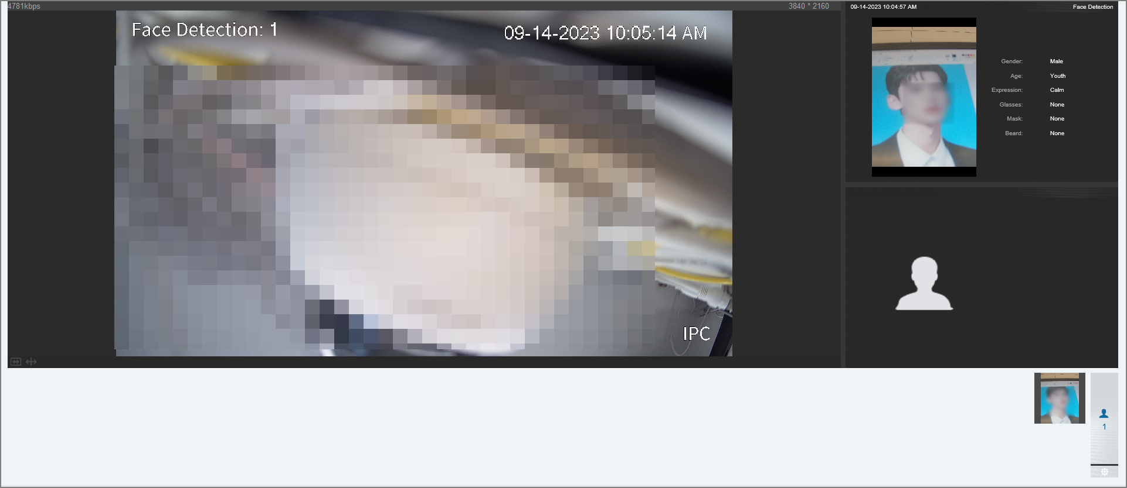
Figure 5-2 AI preview (video metadata)
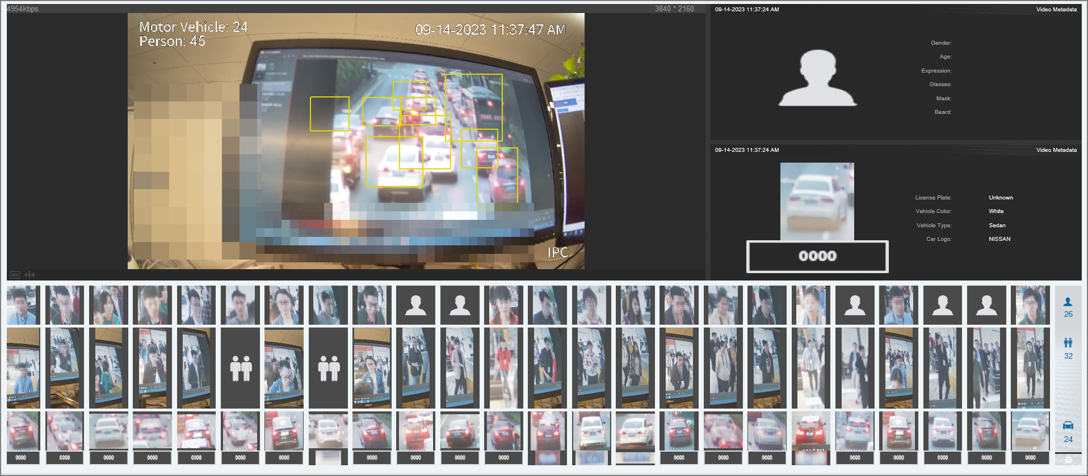

6 Playback
This section introduces playback related functions and operations, including videos and picture.
● Before playing the recording, configure record time range, record storage method, record schedule and record control. For details, see "7.6.1.1 Video Recording".
● Before searching for picture, configure snapshot time range, snapshot storage method, and snapshot plan. For details, see "7.6.4 Snapshot".

6.1 Playback Page
Click the Playback tab.
Figure 6-1 Video
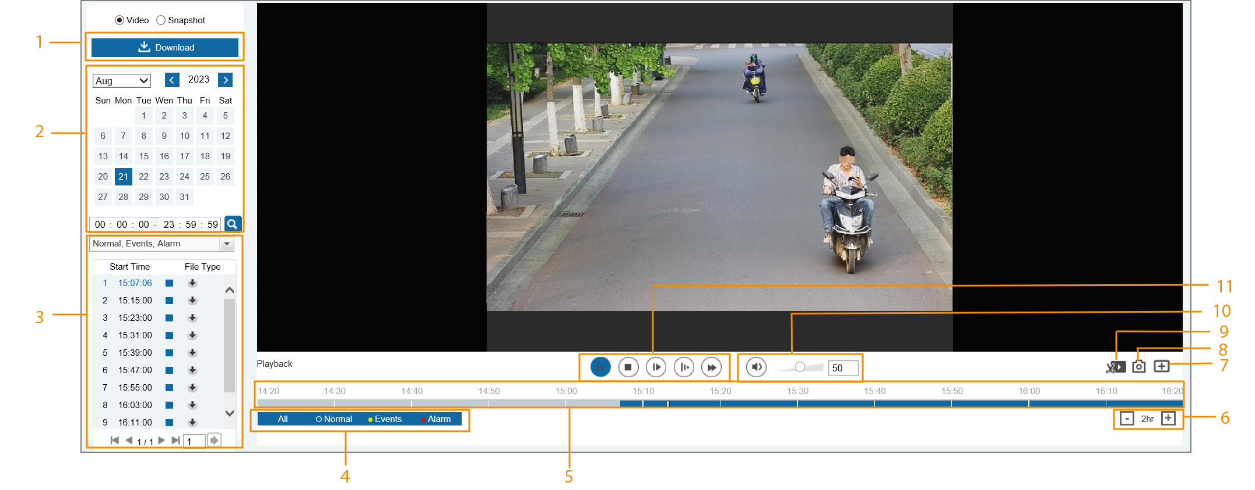
Figure 6-2 Picture
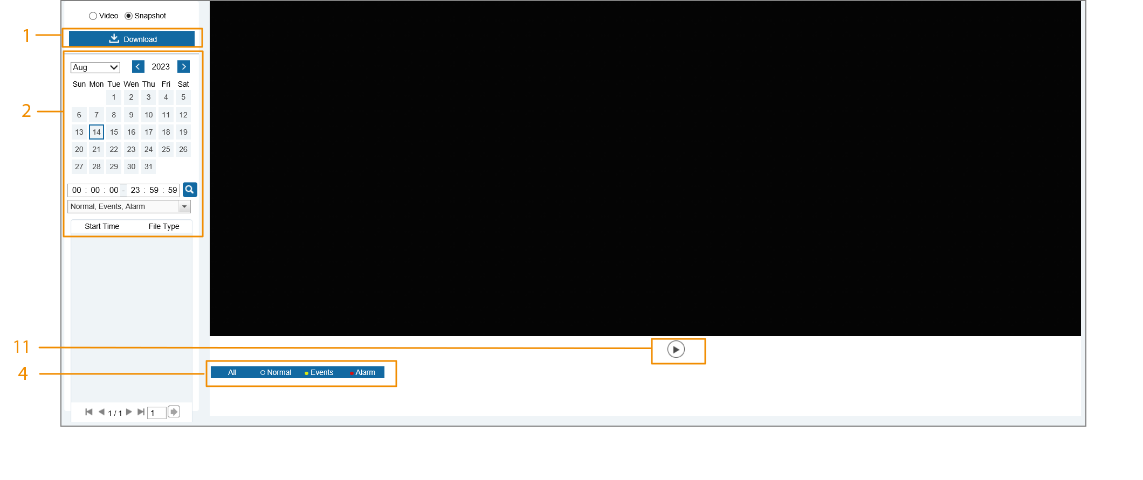
Table 6-1 Playback page description
No. | Function | Description
1 | Download | Download the video or snapshot. For details, see "6.4 Downloading Video or Picture".
2 | Playback file | You can select the record date and time.
3 | Type | You can select the corresponding recording to play and download.
4 | Record/Snapshot Type | Select the record type or snapshot type.
5 | Progress bar | Displays the record type and the corresponding period.  ● Click any point on the colored area, and the system will play back the recorded video from the selected moment.  ● Each record type has its own color, and you can see their relations in Record Type bar.
6 | Time format of progress bar | Includes 4 time formats: 30min, 1hr, 2hr and 24hr. Uses 24hr as an example, the whole progress stands for 24 hours.
7 | Local zoom | You can zoom in or out the video and picture of the selected area through two methods.  ● Click the icon, and then select an area in the video image to zoom in; right-click on the image to resume the original size. In zoom in state, drag the image to check other area.  ● Click the icon, and then scroll the mouse wheel in the video image to zoom in or out.
8 | Snapshot | Click to capture one picture of the current image, and it will be saved to the configured storage path.
9 | Video clip | Clip a certain recorded video. For details, see "6.3 Clipping Video".
10 | Sound | Controls the sound during playback.  ● : Mute mode.  ● : Vocal state. You can adjust the sound.
11 | Play control bar | Controls playback.  ● /: Play or pause recorded videos.  ● : Stop playing back recorded videos.  ● : Play the next frame.  ● : Slow down the playback.  ● : Speed up the playback.

6.2 Playing Video or Picture
This section introduces the operation of video playback and picture playback. This section uses video playback as an example.
Procedure
Step 1 Select Video or Snapshot as needed, and then configure the time.
Step 2 Select the record type from the drop-down list.
Figure 6-3 Playback list
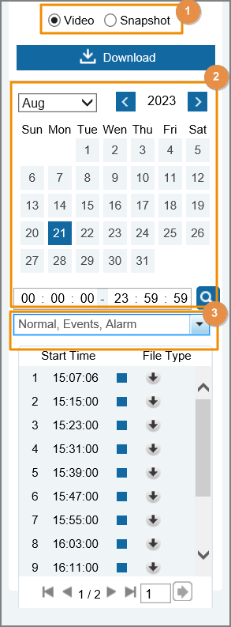
Step 3 Play the video.
● Click in the control bar.
The system plays the recorded video of the selected date (in the order of time).
● Click any point in the colored area on the progress bar.
The playback starts from that moment.
Figure 6-4 Process bar

6.3 Clipping Video
Procedure
Step 1 Select Video, and then configure the time.
Step 2 Select .
Step 3 Click on the progress bar to select the start time of the target video, and then click .
Step 4 Click again on the progress bar to select the end time of the target video, and then click .
Step 5 Click  to download the video.
The system will prompt that it cannot play and download at the same time.
Step 6 Click OK.
The playback stops and the clipped file is saved to the default storage path (C:\Users\admin\WebDownload\PlaybackRecord).

6.4 Downloading Video or Picture
Download video or picture to a defined path. You can download single video or picture file, or download them in batches. This section takes downloading video as an example.
● You can not play or download at the same time.
● Operations might vary with different browsers.

6.4.1 Downloading a Single File
Procedure
Step 1 Select Video, and then configure the time.
Step 2 Select the record type from the drop-down list.
Step 3 Click next to the file to be downloaded.
The system starts to download the file to the default path (C:\Users\admin\WebDownload\PlaybackRecord).

6.4.2 Downloading Files in Batches
Procedure
Step 1 Select Video, and then click Download.
Step 2 In the pop-up page, select the record type, set the start time and end time, and then click Search.
Figure 6-5 Download in batches
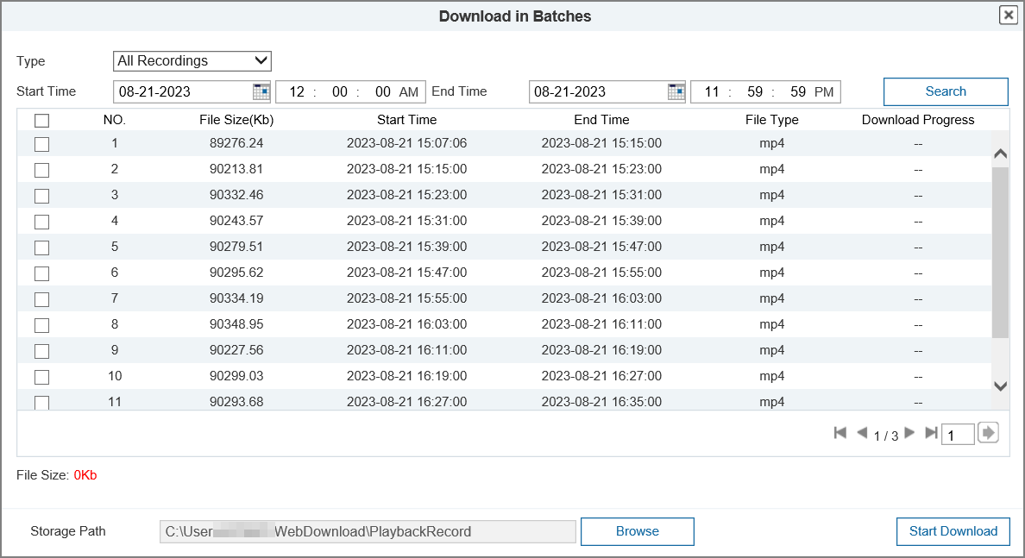
Step 3 Select the files to be downloaded, and then set the storage path.
Step 4 Click Start Download.
The system starts to download the file to the configured path.

7 Setting
This section introduces the basic settings of the camera, including the configuration of system, network, video/audio, image, event and storage.

7.1 System

7.1.1 System Setting

7.1.1.1 Basic Info
Procedure
Step 1 Select Settings > System > System Setting > Basic Info.
Figure 7-1 Basic info
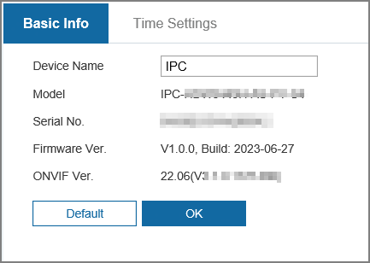
Step 2 (Optional) Set a unique device name. The device name is model name by default.
Step 3 Check the device information such as serial number, firmware version and ONVIF version. Click OK.

7.1.1.2 Time Settings
Procedure
Step 1 Select Settings > System > System Setting > Time Settings.
Figure 7-2 Time settings
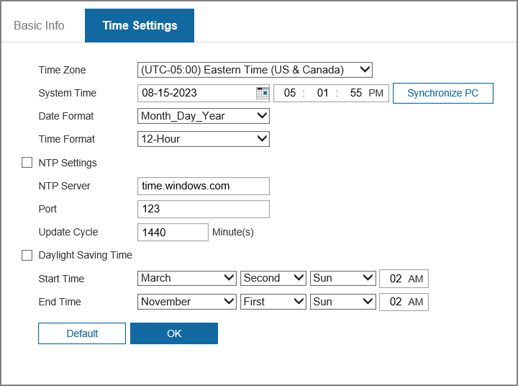
Step 2 Configure the parameters.
Table 7-1 Description of time settings parameters
Parameter | Description
Time Zone | Set the time zone to match the location of the camera.
System Time | Configure system time.  Click Synchronize PC, and then the system time changes to the computer time.
Date Format | Configure the date format.
Time Format | Configure the time format. You can select from 12-Hour or 24-Hour.
NTP Settings | Select the checkbox, and then NTP (network time protocol) is enabled, the system then syncs time with the internet server in real time.  You can also enter the IP address, time zone, port, and interval of a computer which installed NTP server to use NTP.
NTP server
Port
Update Cycle
Daylight Saving Time | Enable it as needed, and then configure start time and end time of daylight saving time.
Step 3 Click OK.

7.1.2 Maintenance

7.1.2.1 Upgrade and Maintenance
You can set the time of auto reboot, back up the configuration file and upgrade system version.
Maintenance
1. Log in to the webpage of the device.
2. Select Settings > System > Maintenance > Upgrade and Maintenance.
Figure 7-3 Maintenance
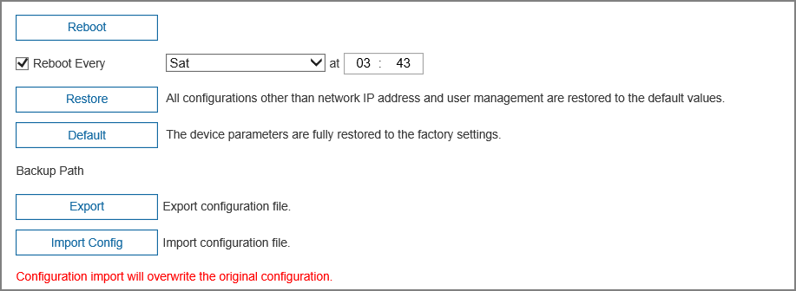
3. You can set the auto reboot time, restore, default, import and export configuration file as needed.
4. Click OK.
Firmware Upgrade
1. Select upgrade method as needed.
● Firmware Upgrade
a. Click Import, and then select upgrade file. The upgrade file should be a Sec_XXX.bin file.
b. Click Upgrade.
● Online Upgrade
Click Manual Detection. If there is any upgrade available, click Upgrade, and then the system starts upgrading.
Figure 7-4 Firmware upgrade
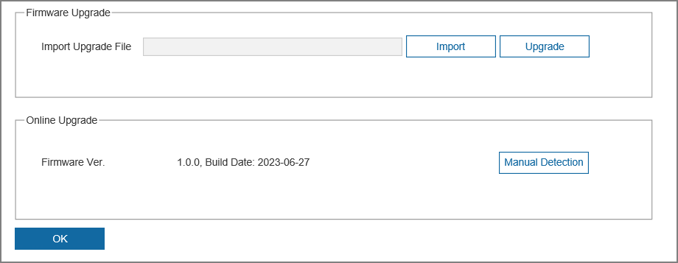

7.1.2.2 System Log
You can view and back up logs.
Procedure
Step 1 Select Settings > System > Maintenance > System Log.
Figure 7-5 System log
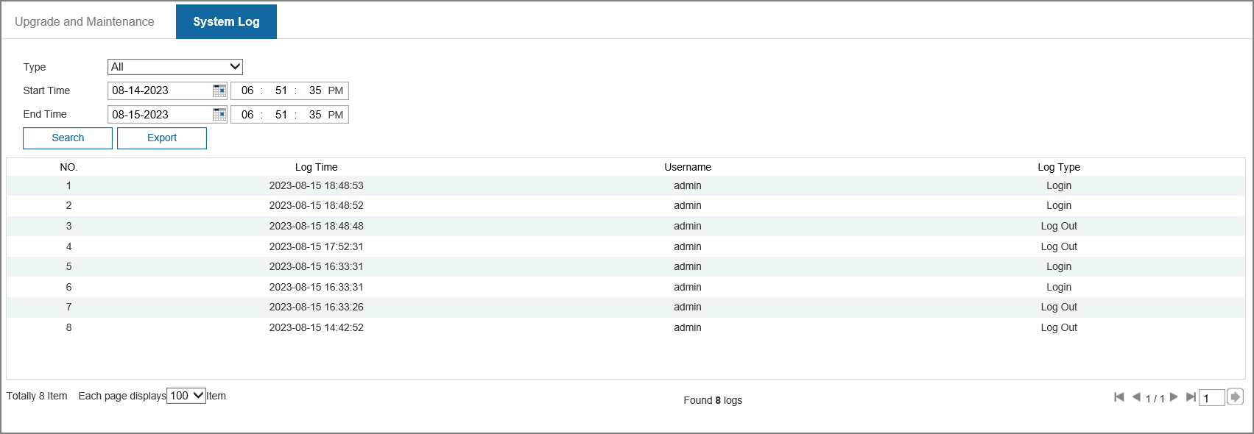
Step 2 Select the log type, and then configure the start time and end time.
The log type includes all, system operations, configuration operations, data management, event operations, recording operations, user management, and security.
● System Operation: Includes program start, abnormal close, close, program reboot, device closedown, device reboot, system reboot, and system upgrade.
● Configuration Operations: Includes saving configuration and deleting configuration file.
● Data Management: Includes configuring disk type, clearing data, hot swap, FTP state, and record mode.
● Event Operations (records events such as video detection, smart plan, alarm and abnormality): Includes event start and event end.
● Recording Operations: Includes file access, file access error, and file search.
● User Management: Includes login, logout, adding user, deleting user, modifying user, adding group, deleting group, and modifying group.
● Security: Includes password resetting and IP filter.
Step 3 Click Search. The system displays the search results.
Step 4 (Optional) Click Backup, and then you can back up all searched logs to local computer.

7.1.3 Security
Configure the IP hosts (devices with IP address) that are allowed to visit the device. Only the hosts in the trusted sites list can log in to the webpage. This is to enhance network and data security.
Procedure
Step 1 Log in to the webpage of the device.
Step 2 Select Settings > System > Security > System Service.
Figure 7-6 System service
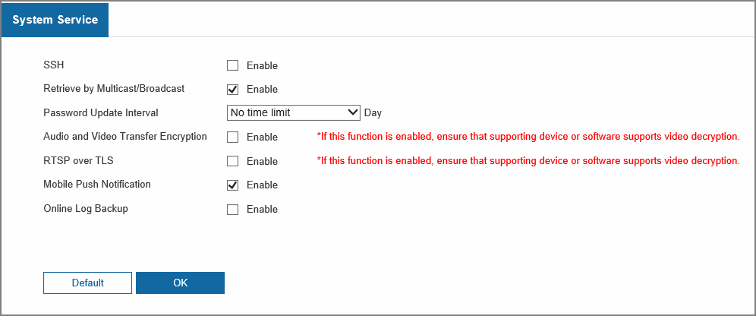
Step 3 Enable the system service as needed.
Table 7-2 Description of system service parameters
Function | Description
SSH | You can enable SSH authentication to perform safety management.
Retrieve by Multicast/Broadcast | Enable this function, and then when multiple users are viewing the device video image simultaneously through network, they can find your device with multicast/broadcast protocol.
Password Update Interval | Configure the password update interval. If the password remains unchanged after the validity period expires, the system will prompt you to change password.
Audio and Video Transmission Encryption | Enable this function to encrypt audio/video transmission.  Make sure that the other devices and software that working together with the camera support video decryption.
RTSP over TLS | Enable this function to encrypt the code transmitted through standard protocols.  ● Make sure that the matched devices or software support video decryption function.  ● We recommend you to enable the function. Otherwise, there might be risk of data leakage.
Mobile Push Notification | Enable this function, and then the system would send the snapshot that was taken when alarm is triggered to your phone. This is enabled by default.
Online Log Backup | Enable this function to back up the online log.
Step 4 Click OK.

7.1.4 User Management

7.1.4.1 User Mana.
You are admin user by default. You can add users, configure different permissions, and edit permissions.

7.1.4.1.1 Username
Procedure
Step 1 Log in to the webpage of the device.
Step 2 Select Settings > System > User Management > User Mana. > Username.
Step 3 Click Add User, and then configure the parameters.
Figure 7-7 Add user (operation permission)
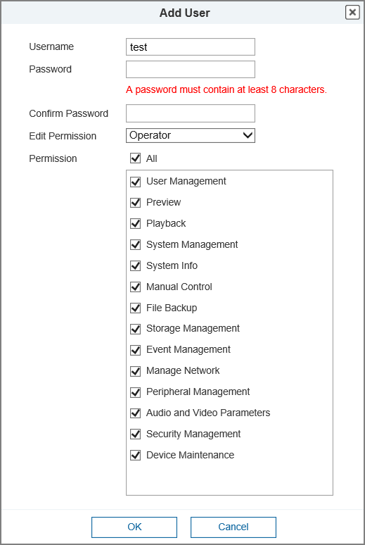
Table 7-3 Description of user parameters
Parameter | Description
Username | The unique identification of the user. You cannot use the existing user name.
Password | Enter password and confirm it again.  The password must consist of 8 to 32 non-blank characters and contain at least two types of characters among upper case, lower case, number, and special character (excluding ' " ; : &).
Confirm Password
Edit Permission | You can select from Operator or User. Different rules have different permissions.
Permission | Select the permissions for the user.
Step 4 Click OK.
Related Operations
● Edit user information
Click to change password and permissions.
For admin account, you can only edit the password.
The methods of changing password vary with different accounts.
◇ Log in with the admin account, you can change password through Old Password and Admin Account.
◇ Log in with non-admin account (an added account with the permission of user management), you can change password through Old Password.
◇ Old Password: Change the password through entering the old password to be changed, and then the new password.
◇ Admin Account: Change the password through entering the admin password, and then the new password for the non-admin account to be changed.
● Delete the user
Click to delete the selected user.
Users and user groups cannot be recovered after deletion.

7.1.4.1.2 User Group
You have two groups named operator and user by default, and you can add new group, delete added group or modify group authority and memo.
Procedure
Step 1 Log in to the webpage of the device.
Step 2 Select Settings > System > User Management > User Mana. > Edit Permission.
Step 3 Click Add Group.
Step 4 Enter the group name, and then select the permissions.
Figure 7-8 Add user group
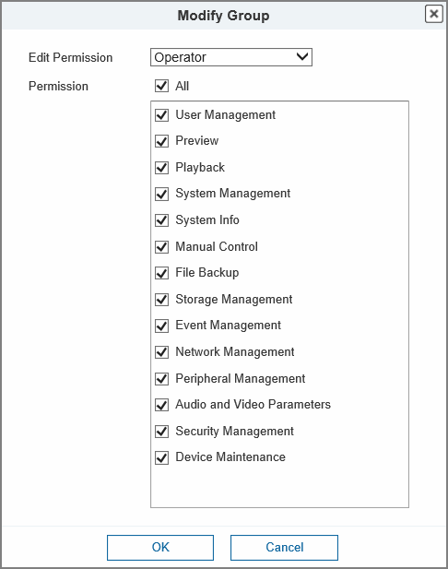
Table 7-4 Description of user group parameters
Permission | Function
Preview | Real-time stream view.
Playback | Playback view.
System Management | System time setting and more.
System Info | Version information, system logs and more.
Manual Control | PTZ settings.
File Backup | File backup.
Storage Management | Storage point configuration, snapshot recording time configuration, SFTP configuration and more.
Event Management | Video detection settings, audio detection settings, alarm settings and more.
Network Management | IP settings, SMTP settings, SNMP settings, AP Hotspot settings and more.
Peripheral Management | External light, wiper and serial port settings.
Audio and Video Parameters | Camera property settings, audio and video settings and more.
Security Management | HTTPS settings, RTSP over TLS settings and more.
Device Maintenance | Automatic maintenance settings and more.
Only user with specified permission can use corresponding function; the Operator group has all the permissions.
Step 5 Click OK to finish the configuration.
The newly added group is displays on the group name list.
Related Operations
● Click to modify group permissions.
● Click to delete the added group. Operator group and User group cannot be deleted.

7.1.4.2 Online User
Check the information of user which is currently online.
Figure 7-9 Online user
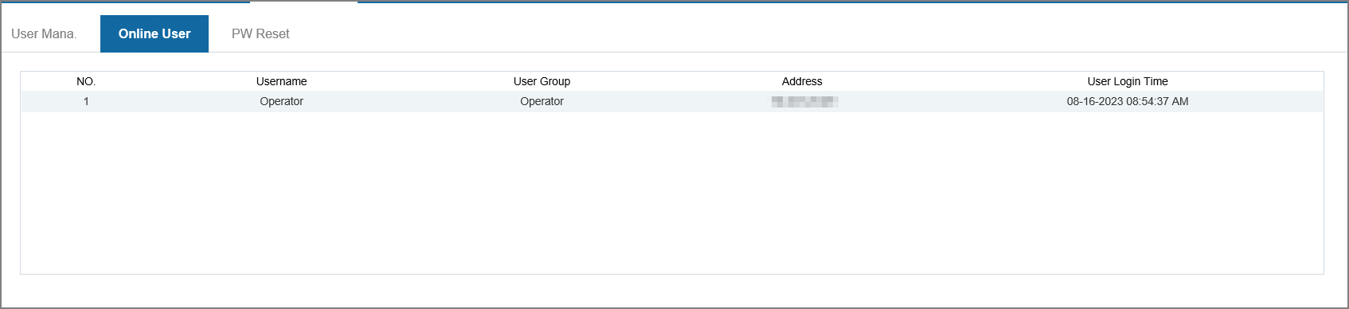

7.1.4.3 PW Reset
Reset the reserved email address for password reset as needed.
Figure 7-10 PW reset
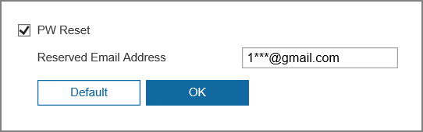

7.2 Network
This section introduces network configuration.

7.2.1 TCP/IP
You can configure IP address and DNS (Domain Name System) server and so on according to network planning.
Prerequisites
The camera has connected to the network.
● If there is no router on the network, assign an IP address on the same network segment.
● If there is a router in the network, set the corresponding gateway and subnet mask.
Procedure
Step 1 Select Settings > Network > TCP/IP > TCP/IP.
Figure 7-11 TCP/IP
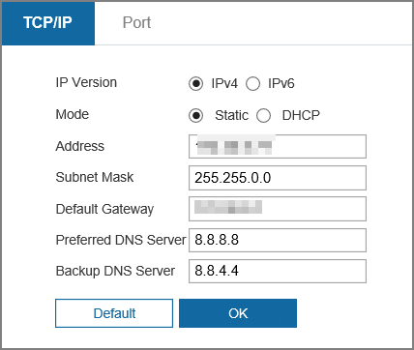
Step 2 Configure TCP/IP parameters.
Table 7-5 Description of TCP/IP parameters
Parameter | Description
IP Version | Select IPv4 or IPv6.
Mode | The mode that the camera gets IP:  ● Static: Configure IP Address, Subnet Mask, and Default Gateway manually, and then click Save, the login page with the configured IP address is displayed.  ● DHCP: When there is DHCP server in the network, select DHCP, and the camera acquires IP address automatically.
MAC Address | Displays host MAC address.
IP Version | Select IPv4 or IPv6.
Address | When you select Static in Mode, enter the IP address and subnet mask that you need.  ● IPv6 does not have subnet mask.  ● The default gateway must be on the same network segment with the IP address.
Subnet Mask
Default Gateway
Preferred DNS Server | IP address of the DNS server.
Backup DNS Server | Alternate IP address of the DNS server.
Step 3 Click OK.

7.2.2 Port
Procedure
Step 1 Select Settings > Network > TCP/IP > Port.
Figure 7-12 Port
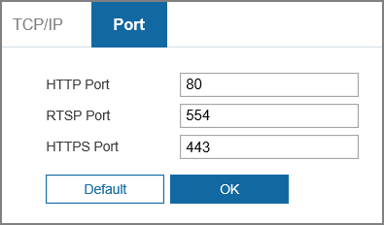
Step 2 Configure port parameters.
● 0–1024, 1900, 3800, 5000, 5050, 9999, 37776, 37780–37880, 39999, 42323 are occupied for specific uses.
● Do not use the same value of any other port during port configuration.
Table 7-6 Description of port parameters
Parameter | Description
HTTP Port | Hyper text transfer protocol port. The value is 80 by default.
RTSP Port | ● Real time streaming protocol port, and the value is 554 by default. If you play live view with QuickTime, VLC or Blackberry smart phone, the following URL format is available.  ● When the URL format requiring RTSP, you need to specify channel number and bit stream type in the URL, and also username and password if needed.  ● When playing live view with Blackberry smart phone, you need to turn off the audio, and then set the codec mode to H.264B and resolution to CIF.  URL format example:  rtsp://username:password@ip:port/cam/realmonitor?channel=1&subtype=0  Among that:  ● Username: The username, such as admin.  ● Password: The password, such as admin.  ● IP: The device IP, such as 192.168.1.112.  ● Port: Leave it if the value is 554 by default.  ● Channel: The channel number, which starts from 1. For example, if you are using channel 2, then the channel=2.  ● Subtype: The bit stream type; 0 means main stream (Subtype=0) and 1 means sub stream (Subtype=1).  Example: If you require the sub stream of channel 2 from a certain device, then the URL should be:  rtsp://admin:admin@10.12.4.84:554/cam/realmonitor?channel=2&subtype=1  If username and password are not needed, then the URL can be:  rtsp://ip:port/cam/realmonitor?channel=1&subtype=0
HTTPS Port | HTTPS communication port. It is 443 by default.
Step 3 Click Apply.

7.2.3 P2P
P2P (peer-to-peer) technology enables users to manage devices easily without requiring DDNS, port mapping or transit server.
Background Information
Scan the QR code with your smartphone, and then you can add and manage more devices on the mobile phone client.
Procedure
Step 1 Select Settings > Network > P2P.
Figure 7-13 P2P
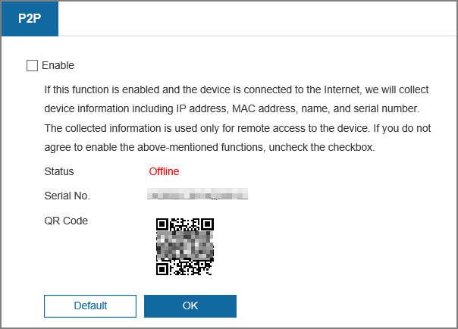
● When P2P is enabled, remote management on device is supported.
● When P2P is enabled and the device accesses to the network, the status shows online. The information of the IP address, MAC address, device name, and device SN will be collected. The collected information is for remote access only. You can cancel Enable selection to reject the collection.
Step 2 Log in to mobile phone client, and then tap Device management.
Step 3 Tap + at the upper-right corner.
Step 4 Scan the QR code on the P2P page.
Step 5 Follow the instructions to finish the settings.

7.2.4 DDNS
Properly configure DDNS, and then the domain name on the DNS server matches your IP address and the matching relation refreshes in real time. You can always visit the camera with the same domain name no matter how the IP address changes.
Prerequisites
Check the type of DNS server supported by the camera.
Procedure
Step 1 Select Settings > Network > DDNS.
● Third-party server might collect your device information after DDNS is enabled.
● Register and log in to the DDNS website, and then you can view the information of all the connected devices in your account.
Figure 7-14 DDNS
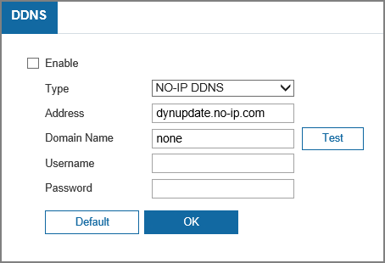
Step 2 Select the Enable checkbox to enable the function.
Step 3 Configure DDNS parameters.
Table 7-7 Description of DDNS parameters
Parameter | Description
Type | The name and web address of the DDNS service provider, see the matching relationship below:  ● CN99 DDNS: www.3322.org.  ● NO-IP DDNS: dynupdate.no-ip.com.  ● Dvrlists: ns1.dvrlists.com.
Address
Domain Name | The domain name you registered on the DDNS website.
Username | Enter the username and password that you got from the DDNS server provider. You need to register an account (includes username and password) on the DDNS server provider's website.
Password
Step 4 Click OK.
Result
Open the browser on your computer, then enter domain name at the address bar and press Enter, the login page is displayed.

7.2.5 Email
Configure email parameter and enable email linkage. The system sends email to the defined address when the corresponding alarm is triggered.
Procedure
Step 1 Select Settings > Network > Email.
Figure 7-15 Email
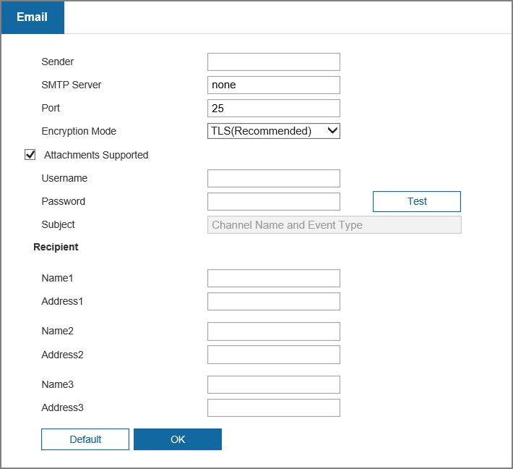
Step 2 Configure email parameters.
Table 7-8 Description of email parameters
Parameter | Description
SMTP Server | SMTP server address | For details, see Table 7-9.
Port | The port number of the SMTP server.
Username | The account and password of SMTP server. Click Test to check whether the email address is available or not.
Password
Sender | Sender’s email address.
Encryption Mode | Select from None, SSL and TLS.  For details, see Table 7-9.
Subject | Enter maximum 63 characters in Chinese, English, and Arabic numerals. Click to select title type, including Device Name, Device ID, and Event Type, and you can set maximum 2 titles.
Attachment Supported | Select the checkbox to support attachment in the email.
Recipient | ● Receiver’s email address. Supports 3 addresses at most.  ● After entering the receiver's email address, the Test button is displayed. Click Test to test whether the emails can be sent and received successfully.
Table 7-9 Description of major mailbox configuration
Mailbox | SMTP server | Authentication | Port | Description
Gmail | smtp.gmail.com | SSL | 465 | You need to enable SMTP service in your mailbox.
Gmail | smtp.gmail.com | TLS | 587 | You need to enable SMTP service in your mailbox.
Step 3 Click OK.

7.2.6 PPPoE
Point-to-Point Protocol over Ethernet, is one of the protocols that device uses to connect to the internet. Get the PPPoE username and password from the internet service provider, and then set up network connection through PPPoE, the camera will acquire a WAN dynamic IP address.
Prerequisites
● The camera has connected to the network.
● You have gotten the account and password from Internet Service Provider.
Procedure
Step 1 Select Settings > Network > Advanced > PPPoE Settings.
Figure 7-16 PPPoE
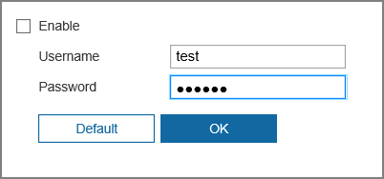
Step 2 Select the Enable checkbox, and then enter username and password.
● Disable UPnP while using PPPoE to avoid possible influence.
● After making PPPoE connection, the device IP address cannot be modified through webpage.
Step 3 Click OK.
The success prompt box is displayed, and then the real-time WAN IP address is displayed. You can access camera through the IP address.

7.2.7 UPnP
UPnP (Universal Plug and Play) is a protocol that establishes mapping relation between local area and wide area networks. This function enables you to access local area device through wide area IP address.
Prerequisites
● Make sure the UPnP service is installed in the system.
● Log in to the router, and configure WAN IP address to set up internet connection.
● Enable UPnP in the router.
● Connect your device to the LAN port of the router.
● Select Settings > Network > TCP/IP > TCP/IP, in Address, enter the local area IP address of the router or select DHCP and acquires IP address automatically.
Procedure
Step 1 Select Settings > Network > Advanced > UPnP.
Figure 7-17 UPnP
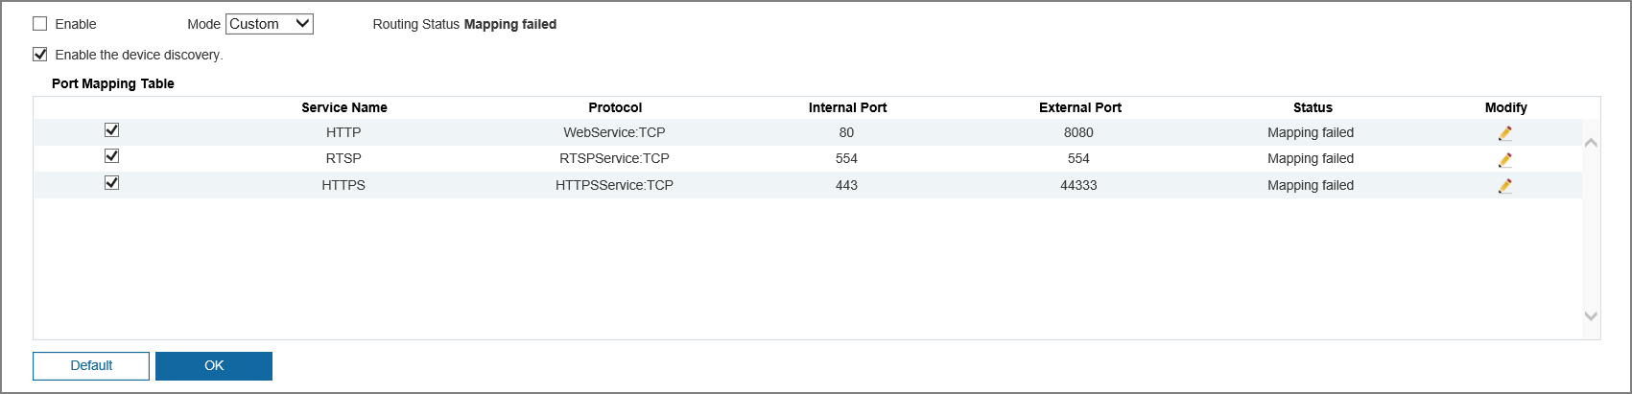
Step 2 Select the Enable checkbox, and there are two mapping modes: Custom and Default.
● Select Custom, click and then you can change external port as needed.
● Select Default, and then the system finishes mapping with unoccupied port automatically, and you cannot edit mapping relation.
Step 3 Click OK.
Open web browser on PC, enter http:// wide area IP address: external port number, and then you can visit the local area device with corresponding port.

7.2.8 SNMP
SNMP (Simple Network Management Protocol), which can be used to enable software such as MIB Builder and MG-SOFT MIB Browser to connect to the camera and manage and monitor the camera.
Prerequisites
● Install SNMP monitoring and managing tools such as MIB Builder and MG-SOFT MIB Browser.
● Get the MIB file of the matched version from technical support.
Procedure
Step 1 Select Settings > Network > Advanced > SNMP.
Figure 7-18 SNMP (1)
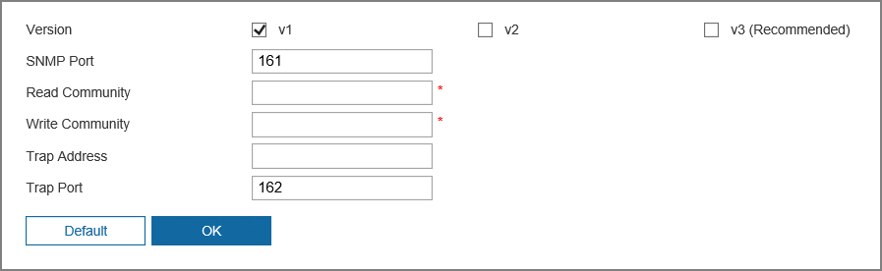
Figure 7-19 SNMP (2)
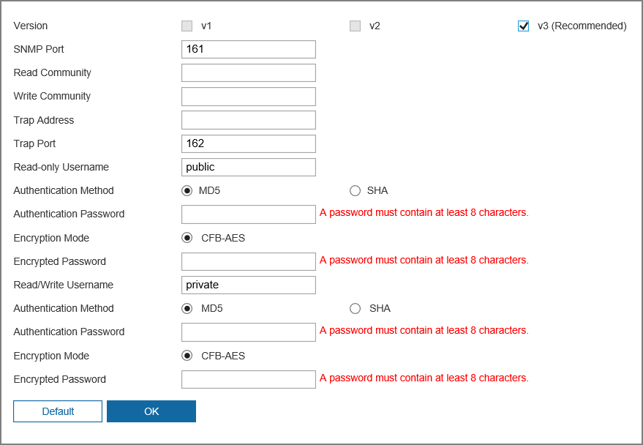
Step 2 Select the version to enable SNMP.
● Select V1, and the system can only process information of V1 version.
● Select V2, and the system can only process information of V2 version.
● Select V3, and then V1 and V2 become unavailable. You can configure username, password and authentication type. It requires corresponding username, password and authentication type to visit your device from the server.
Using V1 and V2 might cause data leakage, and V3 is recommended.
Step 3 In Trap Address, enter the IP address of the PC that has MIB Builder and MG-SOFT MIB Browser installed, and leave other parameters to the default.
Table 7-10 Description of SNMP parameters
Parameter | Description
SNMP Port | The listening port of the software agent in the device.
Read Community, Write Community | The read and write community string that the software agent supports.  You can enter number, letter, underline and dash to form the name.
Trap Address | The target address of the Trap information sent by the software agent in the device.
Trap Port | The target port of the Trap information sent by the software agent in the device.
Read-only Username | Set the read-only username accessing device, and it is public by default.  You can enter number, letter, and underline to form the name.
Authentication Method | You can select from MD5 and SHA. The default type is MD5.
Authentication Password | It should be no less than 8 characters.
Encryption Mode | The default is CBC-DES.
Encryption Password | It should be no less than 8 characters.
Read/Write Username | Set the read/write username access device, and it is public by default.  You can enter number, letter, and underline to form the name.
Step 4 Click OK.
Result
View device configuration through MIB Builder or MG-SOFT MIB Browser.
1. Run MIB Builder and MG-SOFT MIB Browser.
2. Compile the two MIB files with MIB Builder.
3. Load the generated modules with MG-SOFT MIB Browser.
4. Enter the IP address of the device you need to manage in the MG-SOFT MIB Browser, and then select version to search.
5. Unfold all the tree lists displayed in the MG-SOFT MIB Browser, and then you can view the configuration information, video channel amount, audio channel amount, and software version.
Use computer with Windows and disable SNMP Trap service. The MG-SOFT MIB Browser will display prompt when alarm is triggered.

7.2.9 Bonjour
Enable this function, and the OS and clients that support Bonjour would find the camera automatically. You can have quick visit to the camera with Safari browser.
Procedure
Step 1 Select Settings > Network > Advanced > Bonjour.
Figure 7-20 Bonjour
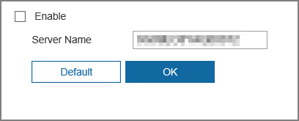
Step 2 Select the Enable checkbox, and then configure server name.
Step 3 Click OK.
Result
In the OS and clients that support Bonjour, follow the steps below to visit the network camera with Safari browser.
1. Click Show All Bookmarks in Safari.
2. Enable Bonjour. The OS or client automatically detects the network cameras with Bonjour enabled in the LAN.
3. Click the camera to visit the corresponding webpage.

7.2.10 Multicast
When multiple users are viewing the device video image simultaneously through network, it might fail due to limited bandwidth. You can solve this problem by setting up a multicast IP (224.0.1.0–238.255.255.255) for the camera and adopt the multicast protocol.
Procedure
Step 1 Select Settings > Network > Advanced > Multicast.
Figure 7-21 Multicast
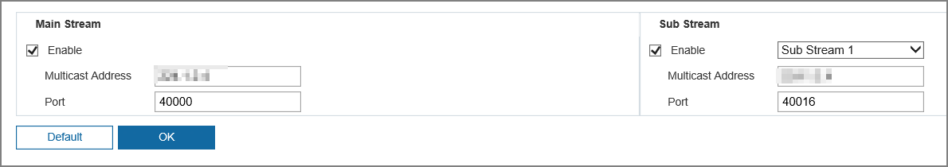
Step 2 Select the Enable checkbox, and then enter multicast address and port.
Table 7-11 Description of multicast parameters
Parameter | Description
Multicast Address | The multicast IP address of Main Stream/Sub Stream is 224.1.2.4 by default, and the range is 224.0.0.0–239.255.255.255.
Port | The multicast port of corresponding stream: Main Stream: 40000; Sub Stream1: 40016; Sub Stream2: 40032, and all the range is 1025–65500.
Step 3 Click OK.

7.2.11 802.1x
Cameras can connect to LAN after passing 802.1x authentication.
Procedure
Step 1 Select Settings > Network > Advanced > 802.1x.
Figure 7-22 802.1x
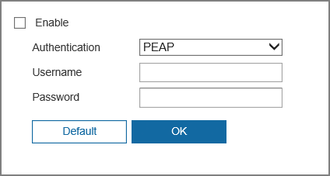
Step 2 Select the Enable checkbox, and then configure the parameters.
Table 7-12 Description of 802.1x parameters
Parameter | Description
Authentication | PEAP (Protected EAP Protocol).
Username | The username that was authenticated on the server.
Password | Corresponding password.
Step 3 Click OK.

7.2.12 QoS
You can solve problems such as network delay and congestion with this function. It helps to assure bandwidth, reduce transmission delay, packet loss rate, and delay jitter to improve experience.
0–63 means 64 degrees of priority; 0 for the lowest and 63 for the highest.
Procedure
Step 1 Select Settings > Network > Advanced > QoS.
Figure 7-23 QoS
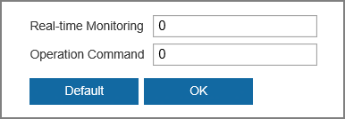
Step 2 Configure QoS parameters.
Table 7-13 Description of QoS parameters
Parameter | Description
Real-time Monitoring | Configure the priority of the data packets that used for network surveillance. 0 for the lowest and 63 for the highest.
Operation Command | Configure the priority of the data packets that used for configure or checking.
Step 3 Click OK.

7.2.13 RTMP
Through RTMP, you can access a third-party platform (such as Ali and YouTube) to realize video live view.
● RTMP can be configured by admin only.
● RTMP supports the H.264, H.264 B and H.264H video formats, and the AAC audio format only.
Procedure
Step 1 Select Settings > Network > Advanced > RTMP.
Figure 7-24 RTMP
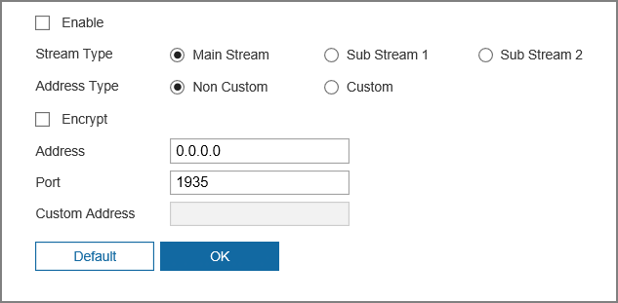
Step 2 Select the Enable checkbox.
Make sure that the IP address is trustable when enabling RTMP.
Step 3 Configure RTMP parameters.
Table 7-14 Description of RTMP parameters
Parameter | Description
Stream Type | The stream for live view. Make sure that the video format is H.264, H.264 B and H.264H, and the audio format is AAC.
Address Type | ● Non-custom: Enter the server IP and domain name.  ● Custom: Enter the path allocated by the server.
Address | When selecting Non-custom, you need to enter server IP address and port.  ● IP address: Support IPv4 or domain name.  ● Port: Keep the default value.
Port
Custom Address | When selecting Custom, you need to enter the path allocated by the server.
Step 4 Click OK.

7.2.14 FTP
FTP can be enabled only when it was selected as a destination path. When the network does not work, you can save all the files to the internal SD card for emergency.
Prerequisites
This function is available only when the video recording type and snapshot type is FTP. For details, see "7.6.2.1 Storage Location".
Procedure
Step 1 Select Settings > Network > Advanced > FTP.
Step 2 Select the Enable checkbox, and then configure the parameters.
You can select FTP or SFTP from the drop-down list. SFTP is recommended to enhance network security.
Figure 7-25 FTP
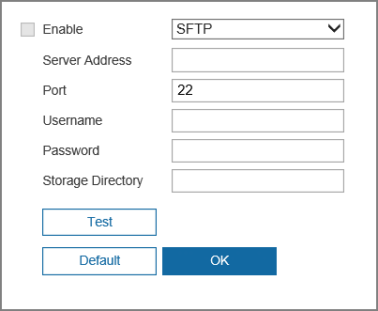
Table 7-15 Description of FTP parameters
Parameter | Description
Server Address | The IP address of the FTP server.
Port | The port number of the FTP server.
Username | The username to log in to the FTP server.
Password | The password to log in to the FTP server.
Storage Directory | The destination path in the FTP server.
Step 3 Click Test to test whether the FTP function works normally.
Step 4 Click OK.

7.2.15 NAS
Enable this function to save all the files in the NAS.
Prerequisites
This function is available only when the video recording type and snapshot type is NAS. For details, see "7.6.2.1 Storage Location".
Procedure
Step 1 Select Settings > Network > Advanced > NAS.
Step 2 Select the Enable checkbox.
Step 3 Configure NAS parameters.
Figure 7-26 NAS
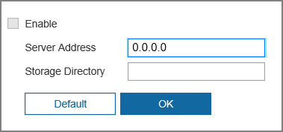
Table 7-16 Description of NAS parameters
Parameter | Description
Server Address | The IP address of the NAS server.
Storage Directory | The destination path in the NAS server.
Step 4 Click OK.

7.2.16 HTTPS
Create a certificate or upload an authenticated certificate, and then you can log in through HTTPS with your computer. The HTTPS can protect page authenticity on all types of websites, secure accounts, and keep user communications, identity, and web browsing private.
Procedure
Step 1 Select the Settings > Network > Advanced > HTTPS.
Step 2 Select Enable HTTPS checkbox.
Figure 7-27 HTTPS
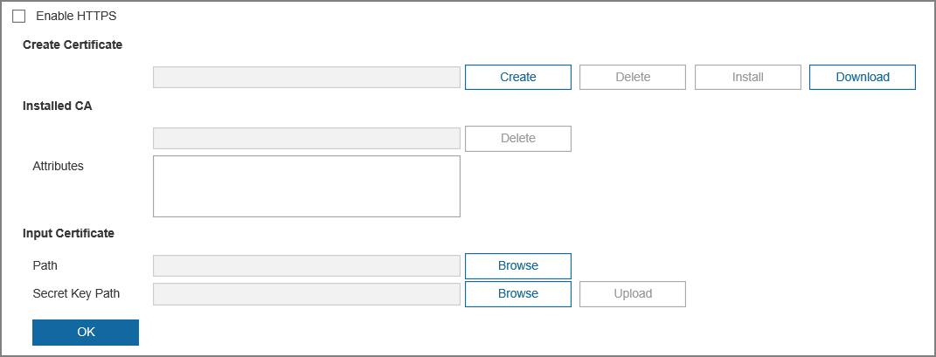
Step 3 Create a certificate or upload an authenticated certificate.
● For creating a certificate, click Create.
● For uploading the authenticated certificate, click Browse to select the certificate and certificate key, click Upload to upload them, and then skip to Step6.
Step 4 Enter the required information, and then click Create.
The entered IP/Domain name must be the same as the IP or domain name of the device.
Step 5 Click Install.
Step 6 Click Download to download root certificate.
Step 7 Click Download Root Certificate.
Figure 7-28 File download
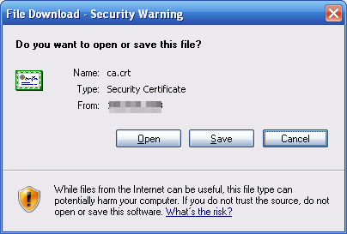
Step 8 Click Open.
Figure 7-29 Certificate information
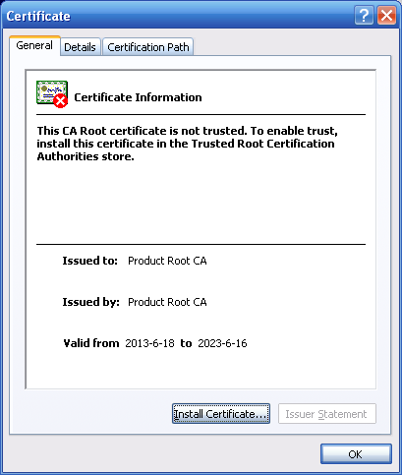
Step 9 Click Install Certificate.
Figure 7-30 Certificate import wizard (1)
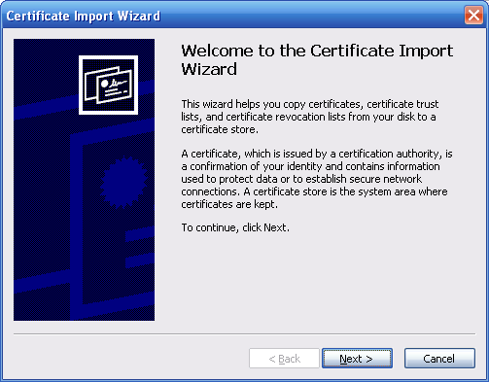
Step 10 Click Next.
Figure 7-31 Certificate store
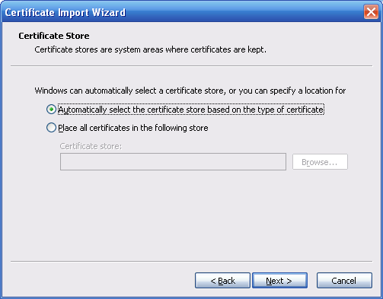
Step 11 Select the storage location and click Next.
Figure 7-32 Certificate import wizard (2)
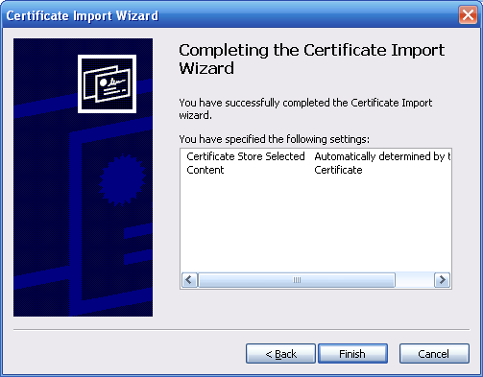
Step 12 Click Finish, and then a dialog box showing The import was successful pops up.
Figure 7-33 Import succeeds
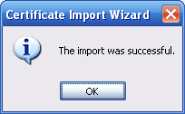

7.2.17 Firewall
Configure Network Access, Disable PING or Half-open Connection Prevention to enhance network and data security. This section takes Network Access as an example.
Background Information
● Network Access: Set allowlist and blocklist to limit access.
◇ Allowlist: Only when the IP/MAC of your computer in the allowlist, can you access the camera. Ports are the same.
◇ Blocklist: When the IP/MAC of your computer is in the blocklist, you cannot access the camera. Ports are the same.
● Disable PING: Enable the Disable PING function, and the camera will not respond to the ping request.
● Half-open connection prevention: Enable Half-open connection prevention function, and the camera can provide service normally under Semijoin attack.
● You cannot set allowlist or blocklist for camera IP or MAC addresses.
● You cannot set allowlist or blocklist for port MAC addresses.
● MAC verification takes effect when the IP addresses of the camera and your computer are in the same LAN.
● When you access the camera through internet, the camera verifies the MAC address according to the router MAC.
Procedure
Step 1 Select Settings > Network > Advanced > Firewall.
Step 2 Select Enable to enable the firewall function.
Figure 7-34 Firewall
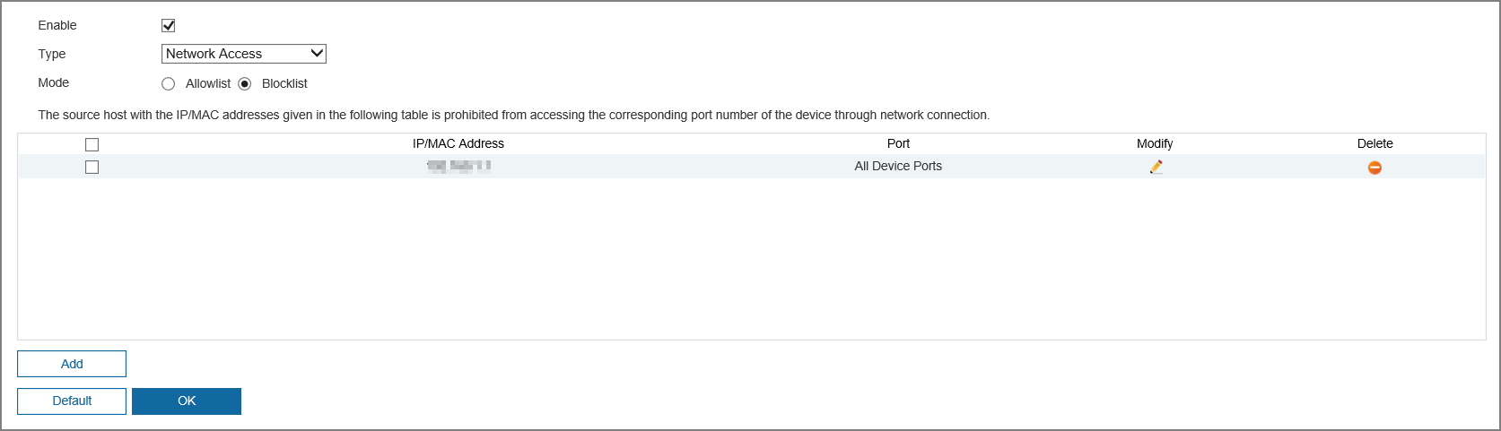
Step 3 Select Network Access from Type list, and then select the mode.
Step 4 Click Add to add the host IP/MAC address to Allowlist or Blocklist, and then click OK.
Figure 7-35 Firewall
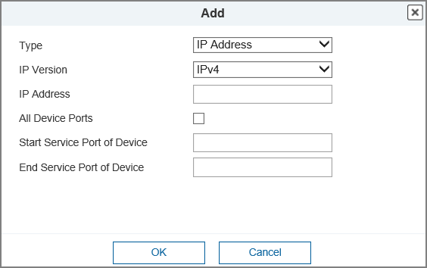
Step 5 Click OK.
Related Operations
● Click to edit the host information.
● Click to delete the host information.

7.2.18 ONVIF
The ONVIF verification is enabled by default, which allows the network video products (including video recording device and other recording devices) from other manufacturers to connect to your device.
Procedure
Step 1 Select Settings > Network > Advanced > ONVIF.
Figure 7-36 ONVIF
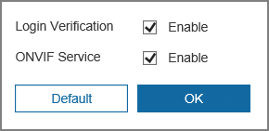
Step 2 Select the Enable checkbox next to ONVIF Verification and ONVIF Service.
Step 3 Click OK.

7.2.19 Remote Log Records
Configure remote log, and then you can get the related log by accessing the defined address.
Procedure
Step 1 Select Settings > Network > Advanced > Remote Log Records.
Step 2 Select Enable checkbox to enable remote log function.
Step 3 Set address, port and device number.
Step 4 Click OK.
Figure 7-37 Remote log
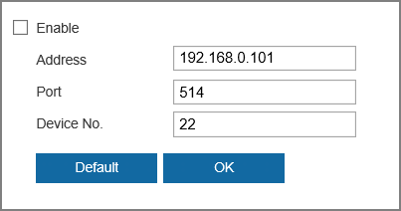

7.3 Video/Audio

7.3.1 Video
This section describes how to set the video stream for the monitoring screen.
Procedure
Step 1 Select Settings > Video/Audio > Video > Video Stream.
Step 2 Configure video stream parameters.
● The stream configuration pages might vary depending on devices.
● The default bit rate of different devices might vary depending on different products.
Figure 7-38 Video stream
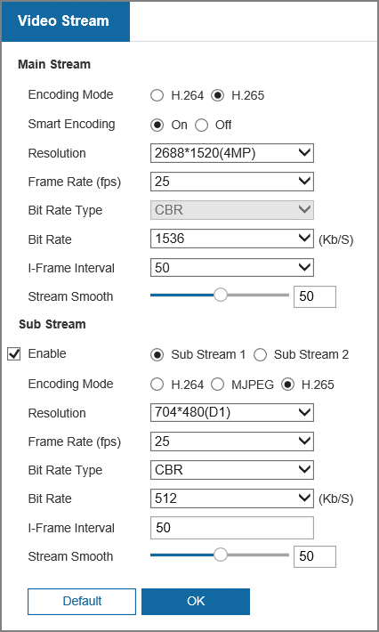
Table 7-17 Description of video stream parameters
Parameter | Description
Encoding Mode | Select encode mode.  Compared with H.264, H.265 requires smaller bandwidth.
Smart Encoding | Enable smart encoding to improve video compressibility and save storage space. It is applicable to static scenes.
Resolution | The resolution of the video. The higher the value, the clearer the image, but the bigger the bandwidth will be required.
Frame Rate (fps) | The number of frame in one second of video. The higher the value is, the clearer and smoother the video will be.
Bit Rate Type | The bit rate control type during video data transmission. You can select bit rate type from:  ● CBR (Constant Bit Rate): The bit rate changes a little and keeps close to the defined bit rate value.  ● VBR (Variable Bit Rate): The bit rate changes as monitoring scene changes.  The Bit Rate Type can be only be set as CBR when Smart Encoding is set as On.
Bit Rate | Select bit rate value in the list according to actual condition.
I Frame Interval | The number of P frames between two I frames. The range varies with the frame rate, and the maximum value is 150. We recommend you set the interval twice the frame rate.
Stream Smooth | Drag to set the value of Stream Smooth.  The higher the value, the less smooth the stream, but the higher the image definition.
Step 3 Click OK.

7.3.2 Audio

7.3.2.1 Configuring Audio
Procedure
Step 1 Select Settings > Video/Audio > Audio > Audio.
Figure 7-39 Audio
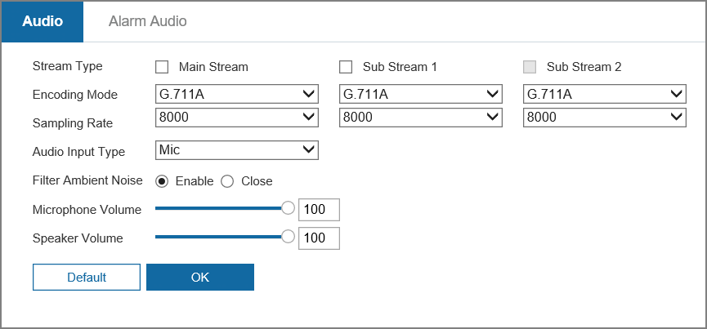
Step 2 Select the stream type from Main Stream, Sub Stream 1 and Sub Stream 2.
Step 3 Configure audio parameters.
Table 7-18 Description of audio parameters
Parameter | Description
Encoding Mode | You can select from PCM, G.711A, G.711Mu, G.726, AAC, G.723.  The configured audio encode mode applies to both audio and intercom. The default value is recommended.
Sampling Rate | Sampling number per second. The higher the sampling rate is, the more the sample in a second will be, and the more accuracy the restored signal will be. You can select from 8000, 16000, 32000, 48000, 64000.
Audio Input Type | You can select audio input type from LineIn, Mic and realMic.
Filter Ambient Noise | Enable this function, the system auto filters ambient noise.
Microphone Volume | Adjusts microphone volume.
Speaker Volume | Adjusts speaker volume.
Step 4 Click OK.

7.3.2.2 Configuring Alarm Audio
You can record and upload alarm audio file. The audio file will be played when the alarm is triggered.
Procedure
Step 1 Select Settings > Video/Audio > Audio > Alarm Audio.
Figure 7-40 Alarm audio
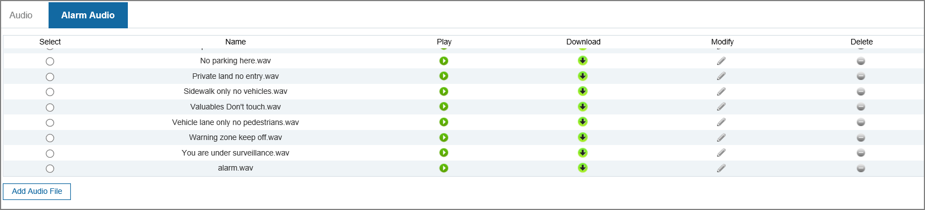
Step 2 Click Add Audio File.
Step 3 Configure the audio file.
● Select Record, enter the audio name in the input box, and then click Record.
● Select Upload, click Browse to select the audio file to be uploaded, and then click Upload.
● The camera supports recording audio file in .pcm format only. Recording is only supported by select models.
● You can upload audio files in .pcm, .wav2, .mp3, or .aac format.
Figure 7-41 Add audio file
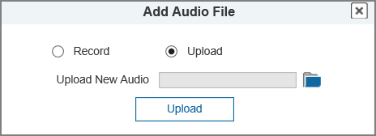
Step 4 Select the file that you need.
Related Operations
● Edit audio file
Click to edit the file name.
● Delete audio file
Click to delete the file name.
● Play audio file
Click to play the file name.
● Download audio file
Click to download the file name.

7.4 Image

7.4.1 Display Settings
Procedure
Step 1 Select Settings > Image > Display Settings.
Figure 7-42 Display settings
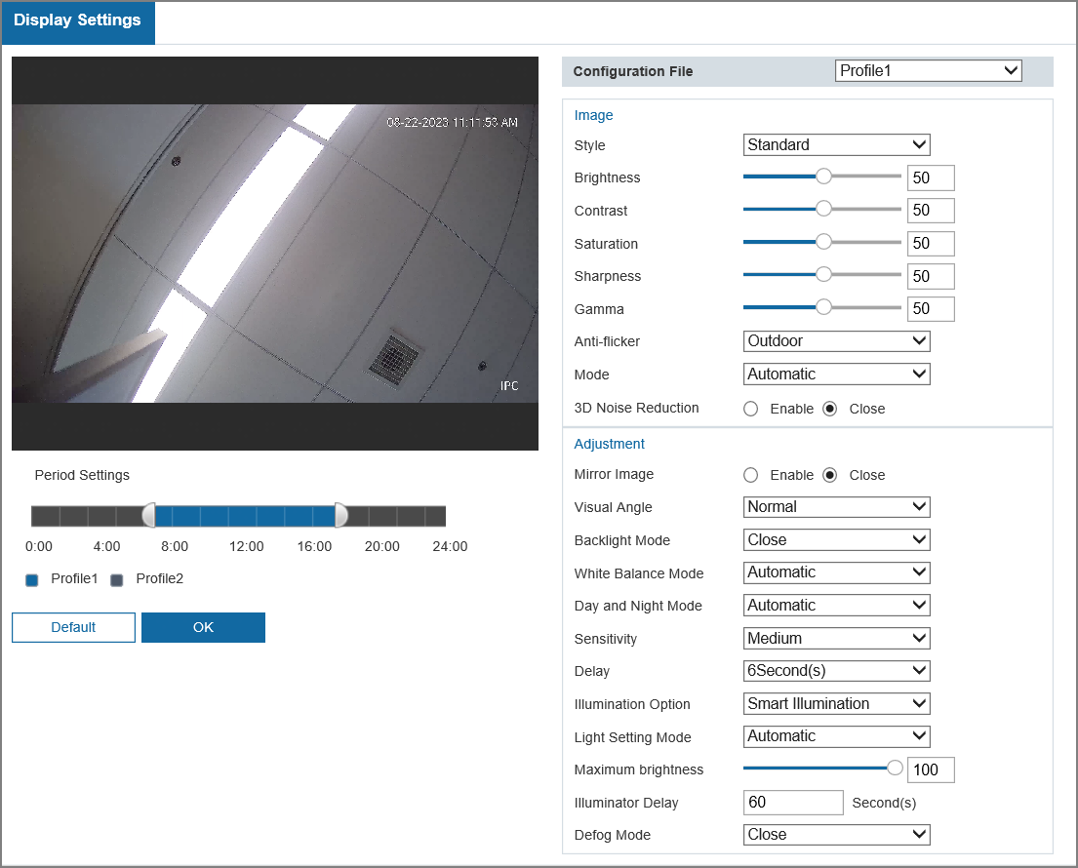
Step 2 Configure the Period Settings.
Profile 1 means daytime; Profile 2 means night. Slide the bar to configure the period for daytime and night correspondingly.
Step 3 Configure the settings for Profile 1 and Profile 2.
Table 7-19 Description of display settings
Parameter | Description
Style | Select the picture style from soft, standard and vivid.  ● Standard: Default image style, displays the actual color of the image.  ● Soft: The hue of the image is weaker than the actual one, and contrast is smaller.  ● Vivid: The image is more vivid than the actual one.
Brightness | Changes the value to adjust the picture brightness. The higher the value is, the brighter the picture will be, and the smaller the darker. The picture might be hazy if the value is configured too big.
Contrast | Changes the contrast of the picture. The higher the value is, the more the contrast will be between bright and dark areas, and the smaller the less. If the value is set too big, the dark area would be too dark and bright area easier to get overexposed. The picture might be hazy if the value is set too small.
Saturation | Makes the color deeper or lighter. The higher the value is, the deeper the color will be, and the lower the lighter. Saturation value does not change image brightness.
Sharpness | Changes the sharpness of picture edges. The higher the value is, the clearer the picture edges will be, and if the value is set too big, picture noises are more likely to appear.
Gamma | Changes the picture brightness and improves the picture dynamic range in a non-linear way. The higher the value is, the brighter the picture will be, and the smaller the darker.
Anti-flicker | You can select from 50 Hz, 60 Hz and Outdoor.  ● 50 Hz: When the electric supply is 50 Hz, the system adjusts the exposure according to ambient light automatically to ensure that there is no stripe appears.  ● 60 Hz: When the electric supply is 60 Hz, the system adjusts the exposure according to ambient light automatically to ensure that there is no stripe appears.  ● Outdoor: You can select any exposure mode as needed.
Mode | Device exposure modes.  ● Automatic: Adjusts the image brightness according to the actual condition automatically.  ● Manual: Configure gain and shutter value manually to adjust image brightness.
3D Noise Reduction | 3D noise reduction is the process of removing noise from a signal. The higher the grade, the less the noise, and the blurrier the image.
Time Domain Level | Calculating the noise reduction by comparing different frames. Sets the value, and it ranges from 0 to 50.
Spatial Domain Level | Take algorithmic noise reduction for single frame picture. Sets the value, and it ranges from 0 to 50.
Mirror Image | Select Enable, and the picture would display with left and right sides reversed.
Visual Angle | Change the display direction of the image.
Backlight Mode | Adjust the backlight compensation mode of the monitoring screen.  ● Close: Backlight is disabled.  ● Backlight Compensation: Backlight compensation corrects regions with extremely high or low levels of light to maintain a normal and usable level of light for the object in focus.  ● Highlight Compensation: Highlight compensation dims strong light, so that the camera can capture details of faces and license plates in extreme light conditions. It is applicable to the entrance and exit of toll stations or parking lots.  ● Wide Dynamic Range: When in WDR (Wide Dynamic Range) mode, the camera constrains over bright areas and compensates dark areas to improve the image clarity.  ● Scene-adaptive: The system automatically adjusts image brightness according to ambient lighting condition to ensure image clarity.
White Balance Mode | White balance function makes the image color display precisely as it is. When in White Balance mode, white objects will always display white color in different environments.  ● Automatic: The system compensates white balance according to color temperature to ensure color precision.  ● Daylight: The system automatically compensates white balance to environments without artificial light to ensure color precision.  ● Street Lamp: The system compensates white balance to outdoor night scene to ensure color precision.  ● Outdoor: The system auto compensates white balance to most outdoor environments with natural or artificial light to ensure color precision.  ● Manual: Configure red and blue gain manually; the system auto compensates white balance according to color temperature.  ● Custom Area: The system compensates white balance only to the set area according to color temperature to ensure color precision.
Day and Night Mode | Configure the display mode of the image. The system switches between color and black-and-white modes according to the actual condition.  ● Automatic: The system switches between color and black-and-white display according to the actual condition.  ● Full Color: The system displays color image.  ● Black & White: The system displays black-and-white image.
Sensitivity | This configuration is available only when you set Auto in Day and Night Mode.  You can configure camera sensitivity when switching between color and black-and-white modes.
Delay | This configuration is available only when you set Auto in Day and Night Mode.  You can configure the delay when camera switching between color and black-and-white mode. The lower the value is, the faster the camera switches between color and black-and-white mode.
Illumination Option | Configure the illumination mode. You can select from Infrared Mode, White Light Mode and Smart Illumination.
Light Setting Mode | You can select form Manual, Automatic and Close.  When select Manual, you can adjust the brightness according to the actual needs.
Defog Mode | The image quality is compromised in foggy or hazy environment, and defog can be used to improve image clarity.  ● Manual: Configure function intensity and atmospheric light mode manually, and then the system adjusts image clarity accordingly. Atmospheric light mode can be adjusted automatically or manually.  ● Automatic: The system adjusts image clarity according to the actual condition.  ● Close: Defog function is disabled.
Step 4 Click OK

7.4.2 OSD
After enabling this function, the selected information will be displayed on the image.
Procedure
Step 1 Select Settings > Image > OSD.
Figure 7-43 OSD
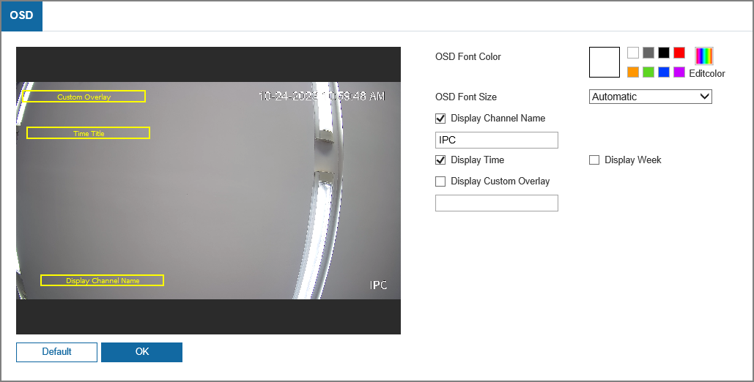
Step 2 Select the color and size of OSD information as needed.
Step 3 Configure the display information, and then click OK.

7.4.3 Privacy Mask
You can enable this function when you need to protect the privacy of some areas on the video image.
Procedure
Step 1 Select Settings > Image > Privacy Mask.
Figure 7-44 Privacy mask
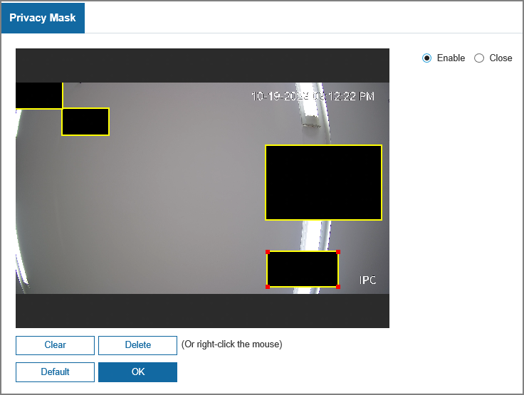
Step 2 Select the Enable, and the image automatically displays 4 blocks.
Step 3 Drag the block to the area that you need to cover, and then adjust the size of the rectangle to protect the privacy.
Step 4 Click OK.
Related Operations
● Click Clear to clear all blocks.
● Click Delete to delete the selected block.

7.5 Event

7.5.1 Basic Event

7.5.1.1 Configuring Motion Detection
The system performs an alarm linkage when a moving object appears in the image and its moving speed reaches the configured sensitivity.
Procedure
Step 1 Select Settings > Event > Basic Event > Motion Detection.
Step 2 Select the Enable checkbox to enable this function.
Step 3 Set the area for motion detection.
Click and drag the mouse to select the area. The detection region can be irregular and discontinuous.
Figure 7-45 Detection area
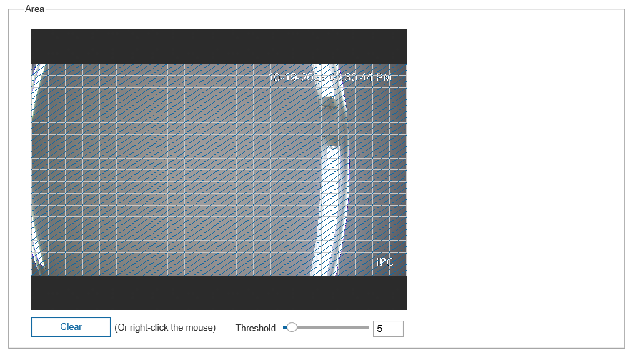
Step 4 (Optional) Select Enable in MD 2.0 area, and then configure the type and sensitivity. The device can detect person, motor vehicle or both as needed.
Figure 7-46 MD 2.0
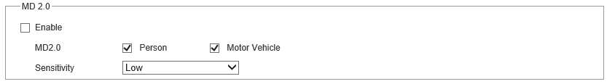
Step 5 Set arming and disarming period.
Step 6 Configure the alarm linkage such as video recording, alarm output. For details, see "7.5.1.5 Configuring Alarm Linkage".
Step 7 Click OK.

7.5.1.2 Configuring Audio Detection
The system performs alarm linkage when vague voice, tone change, or rapid change of sound intensity is detected.
Procedure
Step 1 Select Settings > Event > Basic Event > Audio Detection.
Figure 7-47 Audio detection
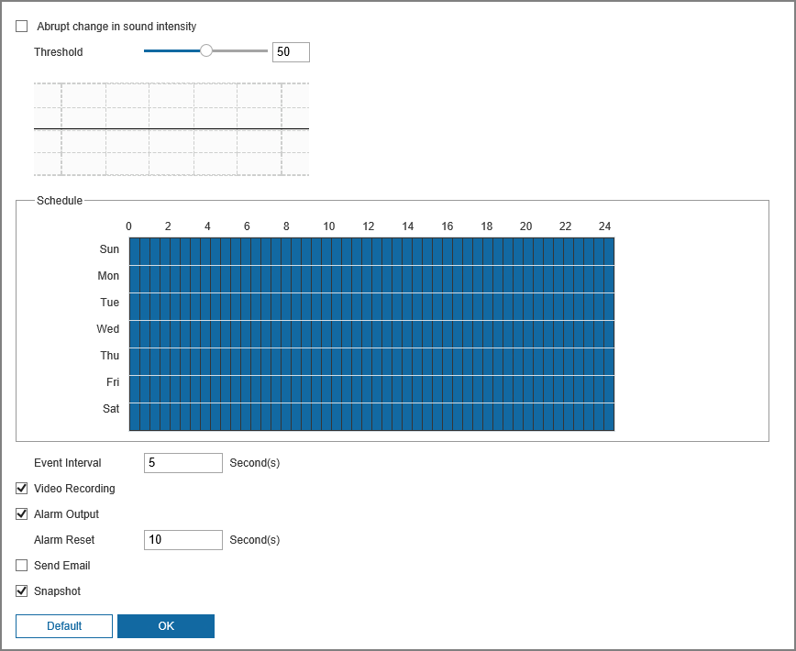
Step 2 Select Abrupt change in sound intensity checkbox, and then set the threshold. The alarm is triggered when the system detects that the sound intensity exceeds the configured threshold.
It is easier to trigger the alarm with smaller threshold. Set a high threshold for noisy environment.
Step 3 Select the schedule and alarm linkage action. For details, see "7.5.1.5 Configuring Alarm Linkage".
Step 4 Click OK.

7.5.1.3 Configuring Video Tampering
The system performs alarm linkage when the lens is covered or video output is mono-color screen caused by light and other reasons.
Procedure
Step 1 Select Settings > Event > Basic Event > Video Tampering.
Step 2 Select the Enable checkbox.
Figure 7-48 Video tampering
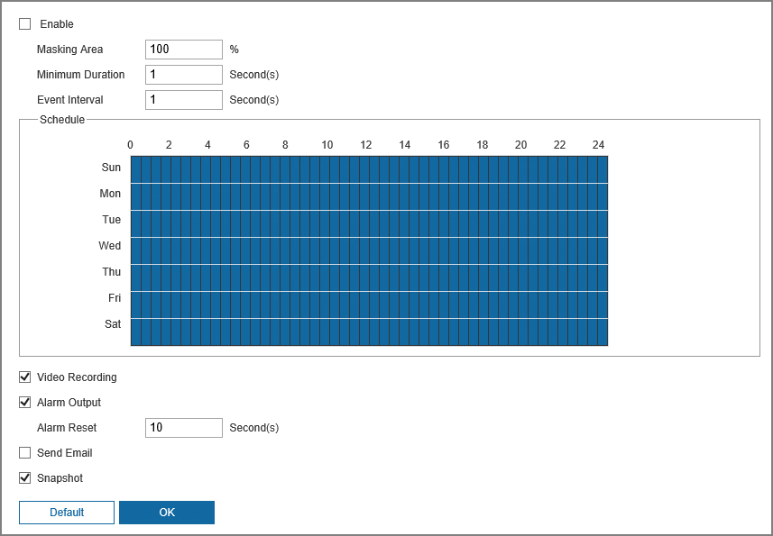
Table 7-20 Description of video temper parameter
Parameter | Description
Masking Area | When the percentage of the tampered image and the duration exceed the configured values, an alarm is triggered.
Minimum Duration
Event Interval | Only record one alarm event during the interval.
Step 3 Set the schedule and alarm linkage action. For details, see "7.5.1.5 Configuring Alarm Linkage".
Step 4 Click OK.

7.5.1.4 Configuring Scene Changing
The system performs alarm linkage when the image switches from the current scene to another one.
Procedure
Step 1 Select Settings > Event > Basic Event > Scene Changing.
Step 2 Select Enable checkbox.
Figure 7-49 Scene changing
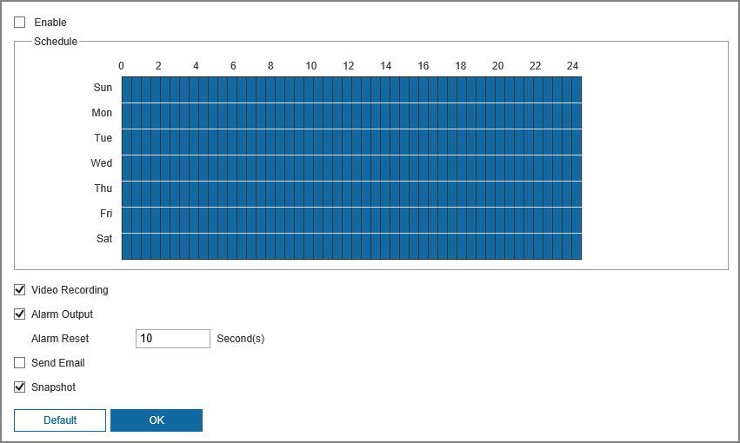
Step 3 Select the schedule and alarm linkage action. For details, see "7.5.1.5 Configuring Alarm Linkage".
Step 4 Click OK.

7.5.1.5 Configuring Alarm Linkage
Procedure
Step 1 Select Settings > Event > Basic Event > Audio Linkage.
Step 2 Select Enable checkbox to enable this function.
Step 3 Select the alarm import, and then configure the schedule.
Press and drag the left mouse button on the timeline to set arming periods. Alarms will be triggered in the period in blue on the timeline.
Figure 7-50 Add the schedule
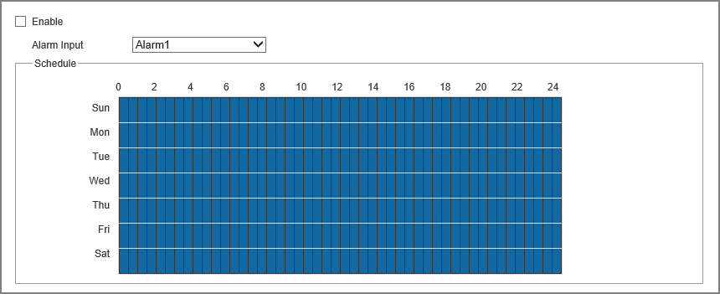
Step 4 Configure the Event Interval and Sensor Type.
● Event Interval: Only record one alarm event during the configured period.
● Sensor Type: You can select from Normally Open and Normally Closed.
Step 5 Configure the corresponding linkage.
● Video Recording: The system can link record channel when an alarm event occurs.
● Alarm Output: When an alarm is triggered, the system can automatically link with alarm-out device.
● Send Email: When an alarm is triggered, the system will automatically send an email to users.
● Audio Linkage: The system broadcasts alarm audio file when an alarm event occurs. For details, see "7.3.2.2 Configuring Alarm Audio".
● Warning Light: When an alarm is triggered, the system can automatically enable the warning light.
● Snapshot: After snapshot linkage is configured, the system can automatically take snapshots when an alarm is triggered.
Step 6 Click OK.

7.5.2 VCA Option
Procedure
Step 1 Log in to the webpage of the device.
Step 2 Click Settings > Event > VCA Option.
Figure 7-51 VCA option
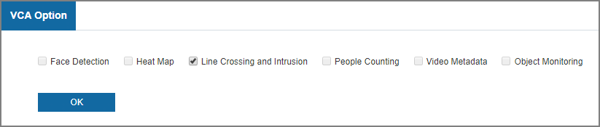
Step 3 Select related checkbox, and then click OK.

7.5.3 Line Crossing and Intrusion
Procedure
Step 1 Log in to the webpage of the device.
Step 2 Click Settings > Event > VCA > Line Crossing and Intrusion.
Step 3 Click to add the rule.
Step 4 In the Type list, select Line Crossing and Intrusion, Parking Detection, People Gathering or Loitering Detection as needed.
This section uses Line Crossing and Intrusion as an example.
● Line Crossing and Intrusion: When the target crosses tripwire from the defined motion direction, an alarm is triggered, and then the system performs configured alarm linkages.
● Parking detection: When the target stays over the configured time, an alarm is triggered, and then the system performs configured alarm linkages.
● People Gathering: When the people gathers or the crowd density is large, an alarm is triggered, and then the system performs configured alarm linkages.
● Loitering Detection: When the target loiters over the shortest alarm time, an alarm is triggered, and then the system performs configured alarm linkages.
Figure 7-52 Configuring line crossing and intrusion
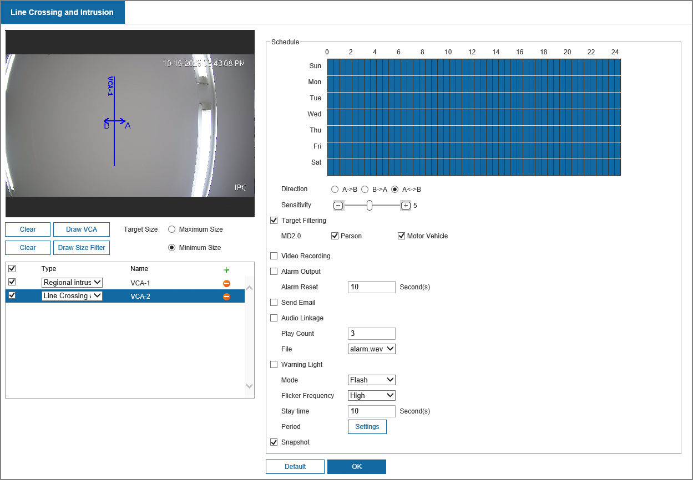
Step 5 Click Draw VCA to draw rule line in the image. Right-click to finish drawing.
Step 6 (Optional) Click other icons to filter targets in the image.
● Select Maximum Size to draw the maximum size of the target; Select Minimum Size to draw the minimum size. Only when the target size is between the maximum size and the minimum size, can the alarm be triggered.
● Click Clear next to Draw VCA to delete the line configured; Click Clear next to Draw Size Filter to delete the rectangle configured.
Step 7 Set rule parameters.
Table 7-21 Description of parameters
Parameter | Description
Direction | Set the direction of rule detection.  ● When setting tripwire, select A->B, B->A, or A<->B.  ● When setting intrusion, select Appear, Cross the region, or Within Area.
Sensitivity | When the sensitivity is high, detection becomes easier, but the number of false detections increases.  Regional intrusion does not support this function.
Target Filtering | Select Target Filtering to enable this function.  ● When you select Person as the alarm target, an alarm will be triggered when the system detects that person trigger the rule.  ● When you select Motor Vehicle as the alarm target, alarm will be triggered when the system detects that vehicle triggers the rule.
Step 8 Configure the alarm schedule and linkage. For details, see "7.5.1.5 Configuring Alarm Linkage".
Step 9 Click OK.

7.5.4 VCA Advanced
This function is available on select models.

7.5.4.1 People Counting

7.5.4.1.1 People Counting Configuration
Background Information
There are 3 types of people counting rules. this section used People Counting as an example.
● People Counting: The system counts the people entering and leaving the detection area. When the number of counted number of people who enter, leave, or stay in the area exceeds the configured value, an alarm is triggered, and the system performs an alarm linkage.
● Regional People Counting: The system counts the people in the detection area and the duration that people stay in the area. When the number of counted number of people in the detection area or the stay duration exceeds the configured value, an alarm is triggered, and the system performs an alarm linkage.
● Queue Management: The system counts the queue people in the detection area. When the queue people number exceeds the configured number or the queue time exceeds the configured time, an alarm will be triggered, and the system performs an alarm linkage.
Procedure
Step 1 Log in to the webpage of the device.
Step 2 Click Settings > Event > VCA Advanced > People Counting.
Step 3 In the Type list, select the type as needed.
Step 4 Click Draw Detection Line to adjust the detection line in the image.
Click Draw VCA to adjust the detection area.
Click Clear next to Draw VCA to delete the area configured; Click Clear next to Draw Detection Line to delete the line configured.
Step 5 Set rule parameters including number of people entered, exit and stay.
Step 6 Configure the alarm schedule and linkage. For details, see "7.5.1.5 Configuring Alarm Linkage".
Step 7 Click OK.

7.5.4.1.2 Viewing People Counting Report
Procedure
Step 1 Log in to the webpage of the device.
Step 2 Click Settings > Event > VCA Report > People Counting Report.
Step 3 Select the report type, start time, end time, and other parameters.
Step 4 Click Search to complete the report.
Click Export to export the statistical report.

7.5.4.2 Heat Map

7.5.4.2.1 Heat Map Configuration
Procedure
Step 1 Log in to the webpage of the device.
Step 2 Click Settings > Event > VCA Advanced > Heat Map.
Step 3 Select the Enable checkbox, and then the heat map function is enabled.
Step 4 Configure the schedule, and then click OK.

7.5.4.2.2 Viewing Heat Map Report
Procedure
Step 1 Log in to the webpage of the device.
Step 2 Click Settings > Event > VCA Report > Heat Map Report.
Step 3 Select the start time, end time and the threshold.
Step 4 Click Search to complete the report.
Click Export to export the statistical report.

7.5.4.3 Object Monitoring
Procedure
Step 1 Log in to the webpage of the device.
Step 2 Click Settings > Event > VCA Advanced > Object Monitoring.
Figure 7-53 Object monitoring
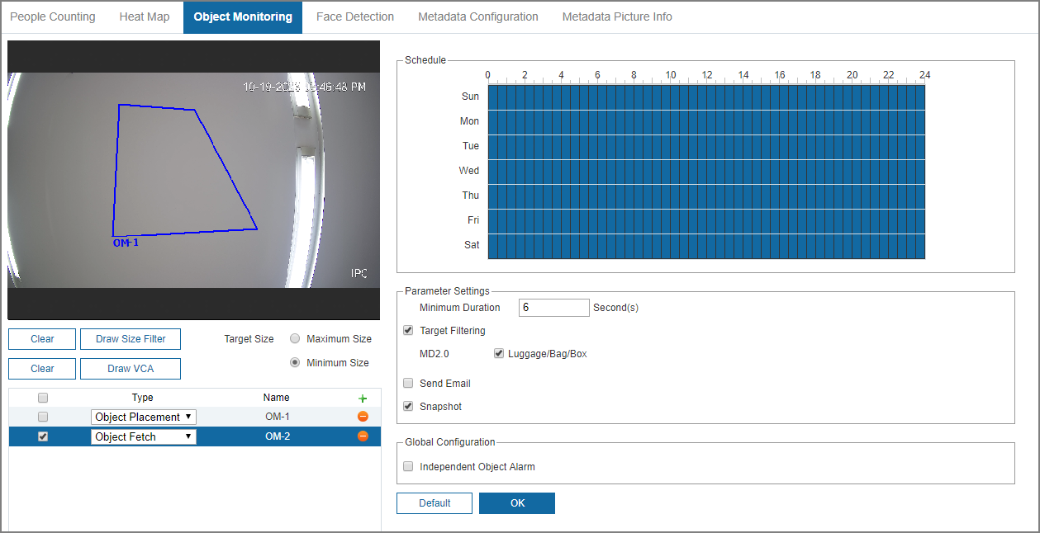
Step 3 In the Type list, select Object Placement or Object Fetch as needed.
● Object Fetch: When an object is taken out of the detection area over the defined time, an alarm is triggered, and then the system performs configured alarm linkages.
● Object Placement: When an object is placed in the detection area over the configured time, an alarm is triggered, and then the system performs configured alarm linkages.
Step 4 Click Draw VCA to draw the detection area.
Click Draw Size Filter, and then select Minimum Size to draw the minimum size of the target; click Maximum Size to draw the maximum size of the target. Only when the target size is between the maximum size and the minimum size, can the alarm be triggered.
Click Clear next to Draw VCA to delete the area configured; Click Clear next to Draw Size Filter to delete the target size.
Step 5 Set the schedule and rule parameters including minimum duration, target filtering.
Step 6 Configure the alarm schedule and linkage. For details, see "7.5.1.5 Configuring Alarm Linkage".
Step 7 Click OK.

7.5.4.4 Face Detection
Procedure
Step 1 Log in to the webpage of the device.
Step 2 Click Settings > Event > VCA Advanced > Face Detection.
Figure 7-54 Face detection
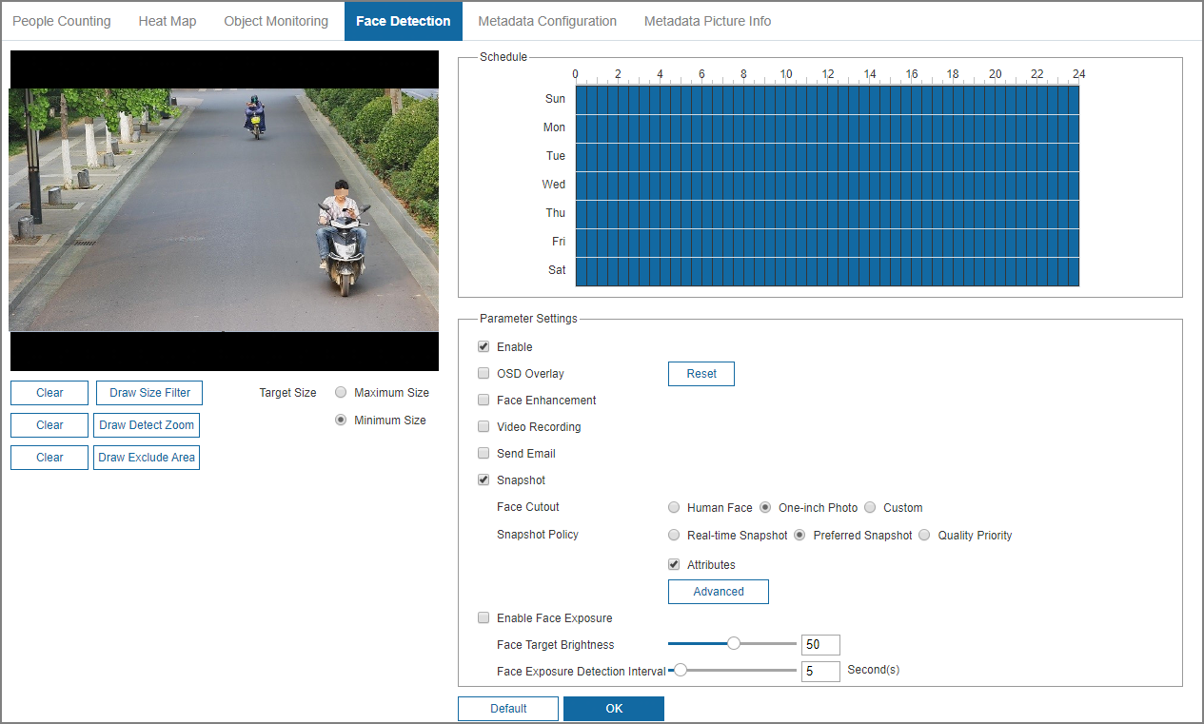
Step 3 Select Enable checkbox.
Step 4 Click Draw Size Filter, and then select Minimum Size to draw the minimum size of the target; click Maximum Size to draw the maximum size of the target. Only when the target size is between the maximum size and the minimum size, can the alarm be triggered.
Step 5 Click Draw Detect Zoom to draw the detection area.
Step 6 Click Draw Exclude Area to draw the exclude area.
Click Clear next to Draw VCA, Draw Detect Zoom and Draw Exclude Area to delete corresponding information.
Step 7 Set the schedule and rule parameters including OSD overlay and face enhancement.
Step 8 Configure the alarm schedule and linkage. For details, see "7.5.1.5 Configuring Alarm Linkage".
Step 9 Click OK.

7.5.4.5 Metadata

7.5.4.5.1 Metadata Configuration
Procedure
Step 1 Log in to the webpage of the device.
Step 2 Click Settings > Event > VCA Advanced > Metadata Configuration.
Figure 7-55 Metadata configuration
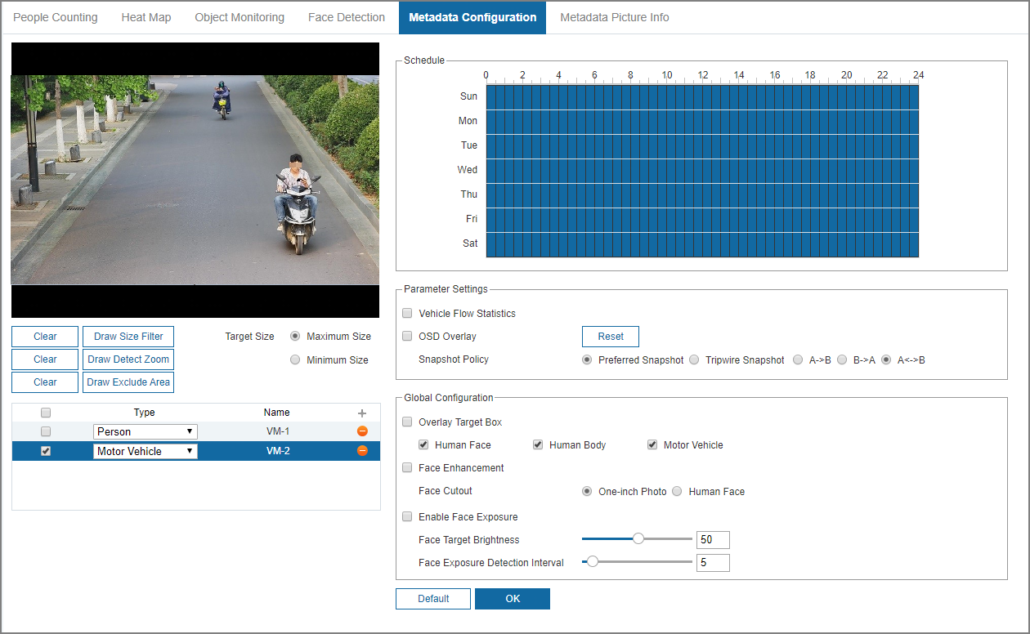
Step 3 Set the global configuration.
Table 7-22 Parameters of global configuration
Parameter | Description
Overlay Target Box | Overlay target box on the captured pictures to mark the target position.
Face Enhancement | Enable this function to preferably guarantee clear face with low stream.
Enable Face Exposure | Enable this function to make face clearer by adjusting brightness and detection interval.
Step 4 In the Type list, select Person or Motor Vehicle as needed.
Step 5 Filter targets in the image.
● Click Draw Size Filter, and then select Minimum Size to draw the minimum size of the target; click Maximum Size to draw the maximum size of the target. Only when the target size is between the maximum size and the minimum size, can the alarm be triggered.
● Click Draw Detect Zoom to draw the detection area. Right-click to finish drawing.
● Click Draw Exclude Area to draw the exclude area. Right-click to finish drawing.
Step 6 Set the schedule and parameters.
Step 7 Click OK.

7.5.4.5.2 Viewing Metadata Report
Procedure
Step 1 Log in to the webpage of the device.
Step 2 Click Settings > Event > VCA Report > Metadata Report.
Step 3 Select the report type, start time, end time, and other parameters.
Step 4 Click Search to complete the report.
Click Export to export the statistical report.

7.5.4.6 Metadata Picture Info
Procedure
Step 1 Log in to the webpage of the device.
Step 2 Click Settings > Event > VCA Advanced > Metadata Picture Info.
Figure 7-56 Metadata picture info
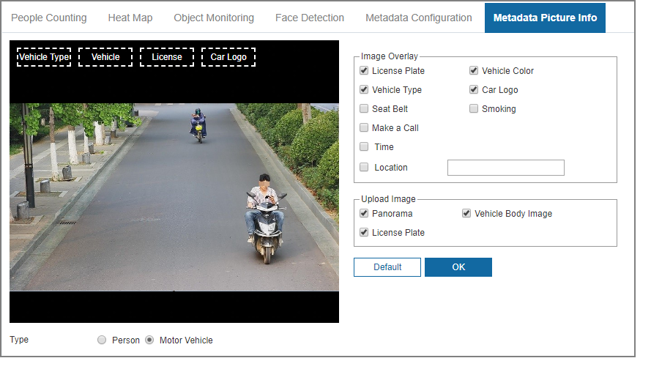
Step 3 Select the type from motor vehicle and person.
Step 4 Select the overlay information and upload image, and then click OK.

7.5.5 Exception
Abnormality includes SD card, network, unauthorized access, voltage detection, and security exception.
Select Settings > Event > Exception.
Abnormal SD card
In case of SD card exception, the system performs alarm linkage. The event types include No SD Card, Insufficient SD Card Space, and SD Card Error. Functions might vary with different models.
1. Select the event type, and then click Enable checkbox to enable this function.
Figure 7-57 Abnormal SD Card
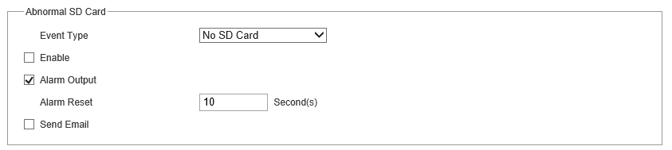
2. Set alarm linkage such as Alarm Output and Send Email. For details, see "7.5.1.5 Configuring Alarm Linkage".
Network Exception
In case of network abnormality, the system performs alarm linkage. The event types include Network Disconnected and IP Conflict.
1. Select the event type, and then click Enable checkbox to enable this function.
Figure 7-58 Network exception
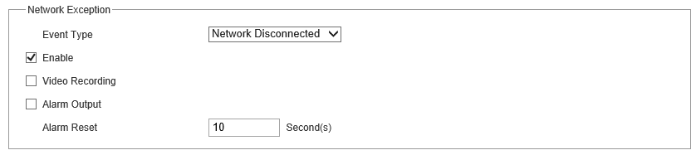
2. Set alarm linkage such as Alarm Output and Video Recording. For details, see "7.5.1.5 Configuring Alarm Linkage".
Unauthorized Access
When the number of login errors exceeds the configured times, the system performs alarm linkage such as alarm output and send email.
Voltage Detection
When the input voltage is higher than or lower than the rated value of the device, the system performs alarm linkage such as OSD, alarm output and send email.
Security Exception
When the system monitors the following events, an alarm can be triggered.
Figure 7-59 Security exception
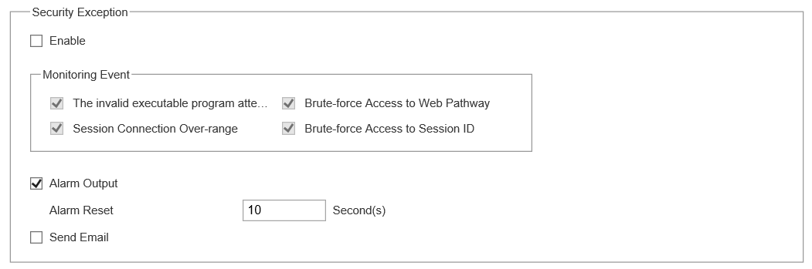

7.6 Storage

7.6.1 Configuring Schedule

7.6.1.1 Video Recording
Procedure
Step 1 Select Settings > Storage > Schedule > Video Recording.
Step 2 Set record plan.
Blue represents normal record plan (such as timing recording); yellow represents motion record plan (such as recording triggered by events). Select a record type, such as Normal, and directly press and drag the left mouse button to set the period for normal record on the timeline.
Figure 7-60 Video recording
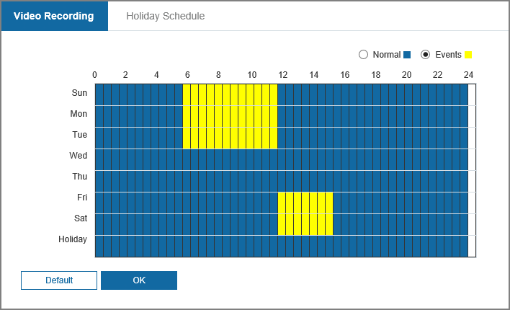
Step 3 Click OK.

7.6.1.2 Holiday Schedule
You can set certain days as holiday, and when the Video Recording or Snapshot is selected in the holiday schedule, the system takes snapshot or records video as holiday schedule defined.
Procedure
Step 1 Select Settings > Storage > Schedule > Holiday Schedule.
Step 2 Select Video Recording and Snapshot as needed, and then configure the time.
Figure 7-61 Holiday schedule
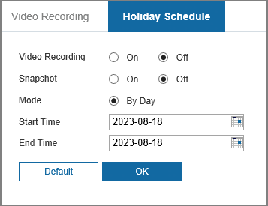
When holiday schedule setting is not the same as the general setting, holiday schedule setting is prior to the general setting. For example, with Holiday Schedule enabled, if the day is holiday, the system snapshots or records as holiday schedule setting; otherwise, the system snapshots or records as general setting.
Step 3 Click OK.

7.6.2 Configuring Storage

7.6.2.1 Storage Location
You can select different storage paths for the recorded videos and snapshots according to event type. You can select from SD card, FTP and NAS.
Procedure
Step 1 Select Settings > Storage > Storage > Storage Location.
Figure 7-62 Storage location
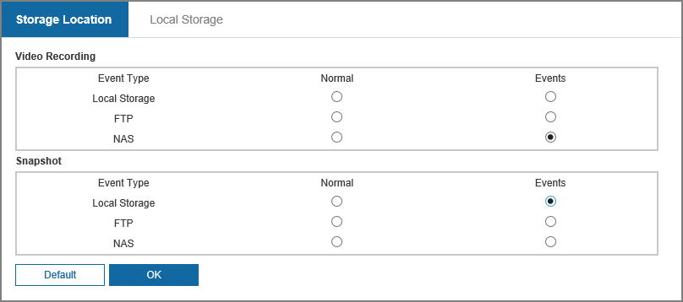
Step 2 Select the storage method that you need for the recorded videos and snapshots of different types.
Table 7-23 Description of storage location parameters
Parameter | Description
Local Storage | Save in the internal SD card.  Local Storage is displayed only on models that support SD card.
FTP | Save in the FTP server.
NAS | Save in the NAS (network attached storage).
Step 3 Click OK.

7.6.2.2 Local Storage
Display the information of the local SD card.
Procedure
Step 1 Select Settings > Storage > Storage > Local Storage.
Figure 7-63 Local storage
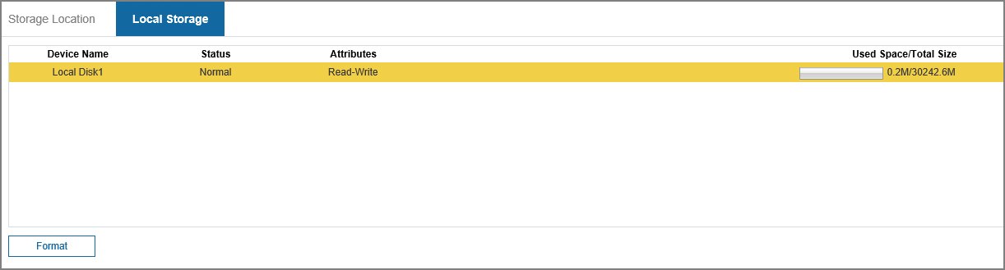
Step 2 (Optional) Click Format to clear the data of the SD card.

7.6.3 Configuring Recording Control
Procedure
Step 1 Select Settings > Storage > Recording Control.
Figure 7-64 Recording control
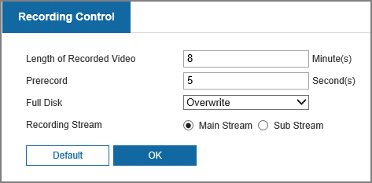
Table 7-24 Description of recording control parameters
Parameter | Description
Length of Recorded Video | The time for packing each video file.
Prerecorded | The time to record the video in advance of a triggered alarm event. For example, if the pre-event record is set to be 5 s, the system saves the recorded video of 5 s before the alarm is triggered.  When an alarm or motion detection links recording, and the recording is not enabled, the system saves the video data within the pre-event record time to the video file.
Full Disk | Recording strategy when the disk is full.  ● Stop: Stop recording when the disk is full.  ● Overwrite: Cyclically overwrite the earliest video when the disk is full.
Recording Stream | Select record stream, including Main Stream and Sub Stream.
Step 2 Click OK.

7.6.4 Snapshot

7.6.4.1 Configuring Snapshot Parameters
Procedure
Step 1 Select Settings > Storage > Snapshot > Parameter.
Figure 7-65 Configuring snapshot parameters
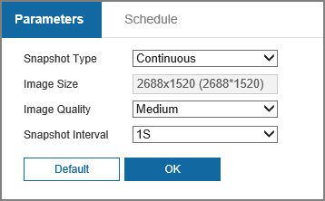
Table 7-25 Description of image stream parameters
Parameter | Description
Snapshot Type | You can select from Continuous and Event.
Image Size | The same resolution with main stream.
Image Quality | Configures the snapshot quality. There are six levels of Image quality, and the sixth is the best.
Snapshot Interval | Configures the snapshot frequency.  Select Custom, and then you can configure snapshot frequency manually.
Step 2 Click OK.

7.6.4.2 Configuring Snapshot Schedule
Procedure
Step 1 Select Settings > Storage > Snapshot > Schedule.
Step 2 Select snapshot type, and then set time period.
Figure 7-66 Configuring snapshot schedule
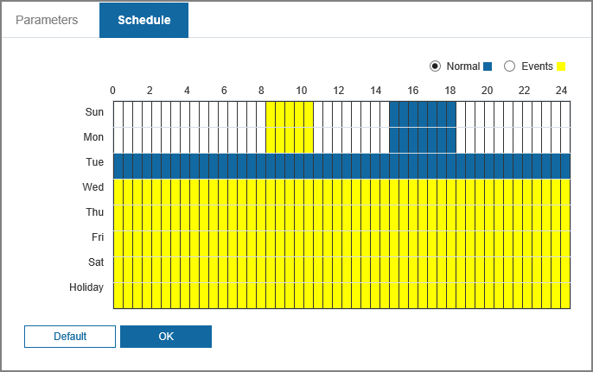
Select snapshot type, such as Events, and directly press and drag the left mouse button to set time period for normal snapshot on the timeline.
Step 3 Click OK.

Appendix 1 Cybersecurity Recommendations
Compulsory measures to ensure the basic device network security:
● Timely Update Firmware and Client Software
◇ Keep the device (such as video recorder and IP camera) firmware up-to-date based on standard procedure in the tech-industry to ensure the system is equipped with the latest security patches and fixes. When the device is connected to the public network, it is recommended to enable the“auto-check for updates” function to obtain timely information of firmware updates released by the manufacturer.
◇ Download and use the latest version of client software.
● Use Complex Passwords with Combination of Characters, Numbers and SymbolsPlease refer to the following suggestions to set passwords:
◇ The length should not be less than 8 characters;
◇ Combine at least two types of characters in a password among upper and lower case letters, numbers and symbols;
◇ Do not contain the account name or the account name in reverse order;
◇ Do not use continuous characters, such as abcdefgh and 12345678;
◇ Do not use overlapped characters, such as aaaaaaaa and 11111111.
Constructive suggestions on improving device network security:
● Change Passwords Regularly
We recommend that you change passwords regularly to reduce the risk of being guessed or cracked.
● Configure and Update Password Reset Information in Time
Password reset function is supported by the device. Please configure related information for password reset in time, including the end user’s email address and password protection questions. Please update the information accordingly in time if it changes. Please do not use simple questions whose answers can be easily obtained when setting password protection questions.
● Enable Account Lock
The account lock is enabled by default. We recommend you keep it on to ensure the account security. A number of failed login attempts will lead the corresponding account and the source IP address to be locked.
● Physical Protection
Physical protection is recommended on the device, especially storage devices. For example, place the device in a special computer room and cabinet, and implement strict access control permission and key management to prevent unauthorized personnel from carrying out physical contacts such as damaging hardware and unauthorized connection of removable device (for example, USB flash drive and serial port).
● Reset Default HTTP and Other Service Ports
Changing the default HTTP and other service ports is recommended. We recommend you change them into any set of numbers between 1024–65535 to reduce the risk of exposing ports in use to outsiders.
● Enable HTTPS
HTTPS is recommended to be enabled so that you can obtain the web service through a secure communication channel.
● Bind IP and MAC Address to Device
To reduce the risk of ARP spoofing, we recommend you bind the IP and MAC address of the gateway to the device.
● Assign Accounts and Privileges Reasonably
Based on business requirements and management requirements, prudently add user accounts and assign a minimum set of permissions to them.
● Disable Unnecessary Services and Apply Secure Modes
If not needed, we recommend you turn off some services such as SNMP, SMTP, and UPnP to reduce risks.
If necessary, we recommend using security modes, including but not limited to the following services:
◇ SNMP: Choose SNMP v3, and set up strong encryption passwords and authentication passwords.
◇ SMTP: Choose TLS to access mailbox server.
◇ FTP: Choose SFTP, and set up strong passwords.
◇ AP hotspot: Choose WPA2-PSK encryption mode, and set up strong passwords.
● Audio and Video Encrypted Transmission
To reduce the risk of losing data during transmission, encrypted transmission is recommended for very important and sensitive audio and video data.
*Reminder: Encrypted transmission might decrease the transmission efficiency.
● Establish a Secure Network Environment
The following actions are highly recommended to ensure device security and to reduce potential cyber risks:
◇ Disable the port mapping function of the router to avoid direct access to the intranet devices from external network.
◇ Partition and isolate the network according to the actual network needs. If there are no communication requirements between two sub networks, we recommend you adopt network isolation through VLAN, network GAP and other technologies.
◇ Establish the 802.1x access authentication system to reduce the risk of unauthorized access to private networks.
◇ Enable IP/MAC address filtering function to limit the range of hosts allowed to access the device.
● Security Auditing
◇ Check online users: Check online users regularly to prevent unauthorized login.
◇ Check device log: Obtain the IP addresses that were used to log in to the device and their key operations with help of the logs.
● Network Log
The stored log is not saved in full due to the limited storage capacity. If you need to save the log for a long time, we recommend you enable the network log function to make sure that the critical logs are synchronized to the network log server for tracing.

